INORGANIC CHEMISTRY
Is about the trends (patterns) in physical and chemical properties of elements and oxides, chloride and hydrides, the elements form.
You will note the similarities and differences in observed trends and attempt to explain in terms of electronegativity, atomic radius, structure and bonding and writing equations.

Main emphasis will be on
- Group (I) and (II)
- Period 3 and first series of transition elements
- Group (V) and (VII)
- Extraction of metals Aluminium, iron, copper and zinc

Our environment is full of inorganic materials, for example water, minerals, air, light and therefore a clear knowledge of inorganic chemistry is very important for our logical thinking.
The physical and chemical properties depend on the atomic structure.

Evidence of atomic structure can be obtained from
- Radio activity
- Ruther ford’s scattering experiment
- Hydrogen spectrum
- Successive ionization energy
- Melting and boiling points
- Structure and bonding
RADIO ACTIVITY
Is the spontaneous decay of an atom with a emission of atleast alpha (α), Beta(β) or gamma (8) rays
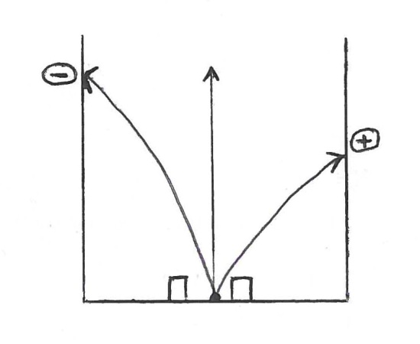
A summary of the properties of radio active particles.

Name (symbol) | Identity | Change | Mass | Penetration and defection
Alpha α | ⁴₂He | ⁺2 | 4 | Low and deflected in away that show it is (+) charged.
Beta β | ⁰-1e | ⁻1 | 0 | High and deflected in away that show it is (-) charged.
Gamma | Rays | - | - | Not deflected.  Very high peneration
Neutron ∩ | ¹₀n | 0 | 1 | Not deflected

NOTE:
- During β – decay there is no change in the mass number, but atomic number increases by one. Therefore decay by β -particles moves the resulting element one place to the right of the periodic table.
- All disintegration by loss of a alpha particle result in decrease in the mass number by 4 and decrease in atomic number by 2. Disintegration by α –particle movesthe resulting element two places to the left of the periodic table.
- Emission by gamma rays (radiation) neither affects the relative atomic mass nor the atomic number and has excess energy which is released in form of gamma rays.

Radioactive equations

There are two
- Parent daughter equation
- Integrated rate equation
Parent daughter equation
- Identify X in the following nuclear reaction
- ¹⁰⁷₄₇Ag + ¹₀n X +⁰₋₁e
Total massnumber on the left = Total mass number on the right.
That is 107 + 1 = X +0
108 =x
Mass number of X = 108
Total atomic number on the left = Total atomic number on the right
47 + 0 = X + -1
X = 48.

Atomic number of X = 48
Then ¹⁰⁸₄₈X and from the periodic table X is Cd.
- ²⁸⁶₉₂U⁹²₃₆Kr + X + ¹⁴¹₅₆Ba
X is 3¹₀n
- Insert the missing data in the following decay chain
²³²₉₀IH X +------- ²²⁸₈₉Ac + -------- b +………..
Solution
²³²₉₀Th x+²²⁸₈₈Ra ²²⁸₈₉Ac + 0-1e b + ²²⁸₉₀Th
NB: Both values of atomic number and mass number must be correct and the symbol should be correct.
Self check:
- Identify element X in the following equations
- ²³⁵₉₂U + ¹₀n ¹⁶⁰₆₂Sn + 4¹₀n + X
- X ²³⁴₉₀Th + ⁴₂He
- ⁴₂He + ¹⁴₇N ¹₁H + X
- ²¹⁴₈₃Bi 3β + 2α + X

Differences between radio activity and ordinary chemical reactions.

Radio activity | Normal chemical equation
- Numberof neutrons and protons change  - React to form new elements  - A small mass of the reactants transformed into energy.  - Mass of reactants is not equal to that of products | - Only number of electrons change.  - React to form a compound  - Energy released or absorbed depends on how much energy is contained in reactants.  - Mass of reactants is equal to that of the products.

The integrated rate equation
Radio activity is a first order reaction
Equation[ N_{o}]of first order is
[N₁]
2.303 log₁₀ = Kt
Where [N)₀ = initial concentration at time t = 0
[N]_{t} = concentration after time t of the decay
K = rate constant
t is time of decay

Half life (t _{½} )
Is the time taken for the concentration of a radio – active material to fall to half of its initial concentration.
Now. 2.303log [N]₀ = Kt _{½}
At t = t _{½} N_{t} = N_{o}
2

2.303log [N]0/[N]0/2 = Kt _{½}
2.303log2 = Kt _{½}
And t _{½} = 2.303log2
K
t_{½}= 0.693
K

Application of radio activity reactions
- In treatment of cancer
- In radio graphy to detect faults in pipes and welded metals
- In preservation of food (tinned food)
- In carbon 14 dating

Lt us revise
- ⁹⁰₃₈Sr is a fo-emitter with half life of 27 years. Determine the time taken for the activity to reduce by 90% of its initial concentration.

Solution
t ½ = 0.693
K
K = 0.693 = 0.693 (years)-1
t_{½}27

And from 2.303log(100/100-90) = Kt
2.303log10 = 0.693 /27 t
And t = 27x2.303/0.693
= 89.7 years.

- If the activity of ²³⁴₉₀Th is reduced to 25% in 48 days. What is the half life of ²³⁴₉₀Th.
Solution:

From 2.303log100/25 = 48K
K=2.303log₁₀4
48
But t _{½}= 0.693
K

= 0.693 X 48
2.303log₁₀4
= 23.99days
= 24 days

Self check:
- The half life of bismuth is 19.7 minutes. Determine the time taken for 43% by mass of bismuthto decay.
- (a)Describe the expression for half life for a first order reaction 2.303log (a₀) Kt where a_{o} is the
a₀-x
initial concentration of the reactant and (a₀-x) is the concentration at time t.
b) the half life of a first order reaction is 100s.
i) calculate the rate constant
ii)Determine the percentage of the reactant that reacted after 250s.

(Ans b(i) 6.93 x10⁻³ S⁻¹ (ii) 82.3%)
- A sample of a radio active element contains 10,000 atoms if the half life of this element is 1.2 minutes , find the number of atoms left after 4.8 minutes (Ans = 625.7)

The structure of the atom and Ruttherfold’s scattering experiment.
When heavy alpha particles were directed at a thin piece of gold foil as shown below.
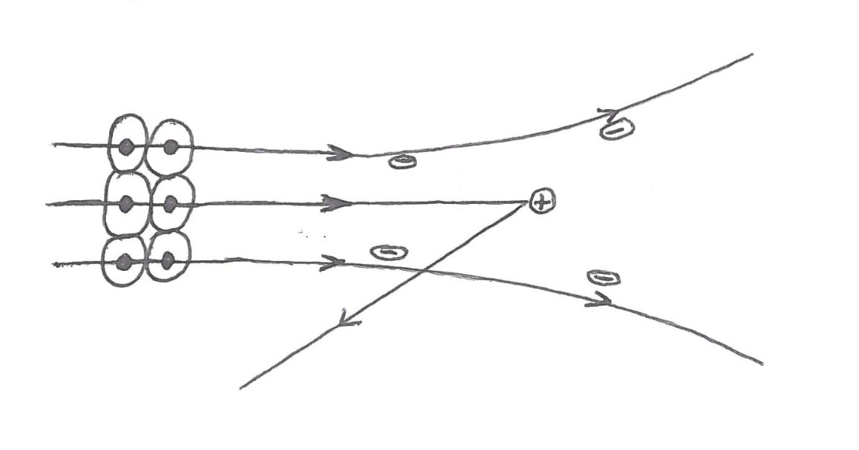
Observation:
Most of them travel in straight lines (passed straight through the foil) and very few were deflected.

Deduction / explanation
The atom is mostly an empty space with a minute central core that is positively charged.

Hydrogen spectrum or atomic spectrum.
When hydrogen in an enclosed glass tube at low pressure is heated by an electric discharge. The molecules splint into atoms which absorb energy.
The excited atom then emit a radiation. If the radiation is passed through shits and a prism an emission spectrum consisting of several lines is obtained.
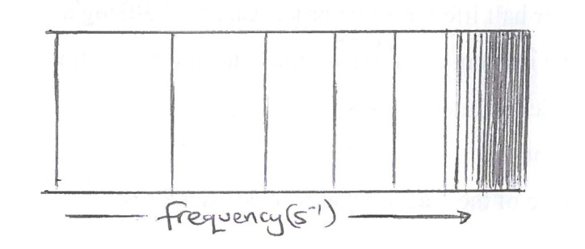
Information that can be obtained from the hydrogen spectrum:
- There are several lines and therefore many energy levels in an atom.
- The spaces separating the lines decrease with increases in frequency.
- The lines are at a definite frequency
- The lines converge into a continum.

Interpretation of the hydrogen spectrum:
- There are several energy levels in an atom and when an electron returns to the lowest energy level, a radiation is emitted and ΔE= hv where ΔE is energy change, h = 6.22x10⁻³⁴ Js⁻¹ is plack’s constant v = frequency.
- Energy emitted or absorbed by an electron is in whole number package called quanta.
- The continum corresponds to complete removal of an electron from the atom (ionization)
- Each element has a characteristic spectrum.

Let us revise
1 a) Describe the spectrum of hydrogen
- Explain how the spectrum of a hydrogen atom
- Is formed
- Provides evidence for existence of energy levels.
- Frequency of hydrogen at a point of ionization is 32.8x10¹⁴HZ. Calculate the ionization energy (plank’s constant = 6.6x10⁻³⁴ s⁻¹

Solution:
- It has series each made of groups of lines. It has both visible and invisible parts. In each series the spacing between adjacent lines decreases and converge into a continuum. That is
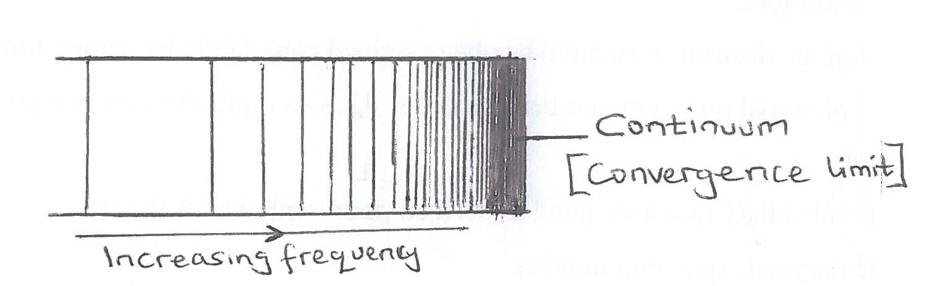

- i) Absorption spectrum is formed when light is shone through hydrogen atoms in an enclosed glass tube at low pressure. Electrons jump from ground state to higher energy levels after absorbing energy of definite amount forming an absorption spectrum recorded on a photographic paper.

(ii) there are series of lines. That is the layman, Balmer, Paschen, Bracket and P- fund series which indicate that electrons fall on different energy levels.
- Hydrogen has one electron yet it produces a spectrum containing many lines, separated from one another indicating that there is sub energy level in an energy level.
- The spacing between adjuscent lines in each series differs indicating movement of electrons from different energy levels.
- There is a continuum in each series of lines, which shows movement of electrons with different frequencies.
- The lines have different wave length.

C) using
ΔE = hv
= 6.6x10⁻³⁴ x 32.8x10¹⁴
= 2.1648x10⁻¹⁸ joules / atom

Self check
- Calculate the energy required to ionize 1mole of hydrogen atoms given that the frequency of the convergence limit of the lines of atomic hydrogen is 3.28x10¹⁵Hz. Avayodro’s constant is 6.02x10²³mol⁻¹ and Plank’s constant h= 6.62x110⁻³⁴Js
(Ans 130.72x10⁴Jmol⁻¹)

- When alpha particles are directed at a thin gold foil most of them passed through undeflected. Explain the observation.

Quantum Numbers:
The energy of an electron in an atom can be described completely by stating four quantum numbers.
- The principal quantum number denoted n, 12, -,-,- represents the energy and size of the energy level.
- The subsidiary quantum number denoteded (represented by S,P,d,f
- The magnetic quantum number
- The spin quantum number.

Rules on electron filling in orbitals, denotes

- Each orbital may hold upto two election. And no two electrons in one atom can have all four quantum numbers thatare the same.(Pauli’s exclusion principle). Therefore the number of electrons possible in each energy level (shell) is 2n²

Shell number | Maximum number of electrons accommodated
1 | 1S² = 2
2 | 25²2P⁶ = 8
3 | 35²3P⁶3d ¹⁰ = 18
4 | 45²4P⁶4d¹⁰4f¹⁴ =32

- Electrons enter the lowest energy level available (Aulban principle)
- Orbitals of same energy are occupied singhly before paring occurs (Hand;s rule). Therefore the relative order of energy levels can be generated as follows:-
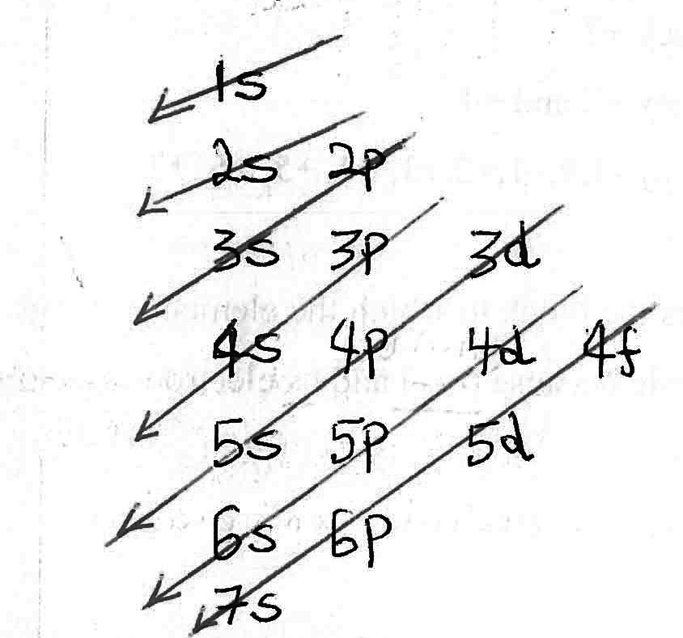
That is, 1s2s2p3s3p4s3d4p5s
Example
11Na = 2:8:1 1S²2S²2P⁶3s¹
19K = 2:8:9 1S²2S²2P⁶3s²3P⁶4s¹
Note: the O-Level approach is now omitted

Check:
₁₈Ar = Is²2s²2p⁶3s²3p⁶ it is full (stable)
Then ₁₉K = Is²2s²2p⁶3s²3p⁶4s¹
= [Ar]4s¹
₂₁Sc = Is²2s²2p⁶3s²3p⁶3d¹4s²
= [Ar]3d¹45²

Self check:
Write the electronic configuration of the following elements:
- Manganese
- Nickel
- Zinc
- Strontium
- Tin
- Iron
Special features relating to electronic configuration:
- Elements in the same group have similar outer most electronic configuration example.
Group I has ns¹ valency + 1
Group II has ns² valency +2
Group IV has ns²np² valency +2 and +4
Group VII has ns²np⁵ valency -1,0,+1,+2,+3, +4, +5, +6, +7

Also, the outermost electronic configuration shows the block to which the element belongs.
The first series of transition elements are an example because (n-1)d and ns electrons are involved in bonding.
Example ₂₂Ti Is²2s²2p⁶3s²3p⁶3d²4s²
So Ti can show a valency of +2, +3, and +4

Self check:
1.State the valencies of the following elements that can be used in bonding
- Iron
- Copper
- Chromium
- Manganese
- Cobalt
- Nickel

- Chronium and copper
The two have a unique electronic structure because of half filled and fully filled sub shells respectively are favoured in their formation.
There fore Cr is 3d⁵45¹ and not 3d⁴45²X
And Cu is 3d¹⁰45¹ and not 3d⁹45²X
2.The atomic number of element A IS 33.
- Write the electronic configuration of A.
- Write the formula of oxide of A.

Physical properties of elements and compounds:
- Atomic radius
- Ionization energy
- Electron affinity and electronegativity
- Melting and boiling points
- Electrical conductivity
- Structure and bonding

The first three properties (a) to (c) are known as atomic properties because a single atom is involved and these properties are related to the rest of the properties (d) to (f) which take place in bulk.
Ionization energy ΔHº_{I}E:
Is the enthalpy required to remove one mole of electrons from one mole of gaseous atoms or ions at 25ºc and one atmosphere to form gaseous ions.

Example Mg(g) Mg⁺(g) +e ΔHº_{I}E__________1
Mg⁺(g) Mg²⁺(g) +e ΔHº_{I}E __________2

Equation (1) shows the first ionization energy of magnesium and equation 2) the second ionization energy of Magnesium.

First ionization Energy:
Is the energy required to remove one mole of electron from one mole of gaseous atoms at 25ºc and one atmosphere to form gaseous ions.
Example Na(g) Na⁺(g) +e

Successive ionization energy
Is the removal of all electrons from a gaseous atom to form a gaseous ion at standard conditions.
Example: sodium ₁₁Na has 11 electrons,Therefore the successive ionization energy of sodium is when all the 11 electrons have been removed.
NOTE:
The pattern of the values to the principal energy levels should be related to:-
- The period and group the element belongs in the periodic table
- The valency or oxidation number of the atom.

- Trend in first ionization energy across a period:
- Elements of the third short period of the periodic table.

Element Na Mg Al Si P S Cl Ar

1st J.E (KJmol-1) 500 730 590 860 1260 1000 1260 1330

Explanation:
There is a general increase in ionization energy from Na to Ar with two unexpected decrease at aluminium and sulphur.

Across the period 3, the nuclear charge increases as atomic radius decreases, this is because each successive electron added enters an already existing shell and such electrons shield each after poorly from the increasing effective nuclear change, therefore atomic radius decreases.
The increase at Magnesium and phosphorous is because of the electronic configuration ₁₂Mg is Is²2s²2p⁶3s² has a full 352 sub shell while ₁₅P is 1s²2s²2p⁶3s¹3p³ has exactly a half filled 3p sub shell.

These require more energy to remove one electron because of their special stability. The unexpected decrease of aluminium and sulphur are due to their electronic structure with 3p sub shell which is under half filled₁₃Al²25²2P⁶35²3P¹, ₁₆S15²25²2P⁶35²3P⁴ and requires less energy to be disrupted.
- Trend in first ionization energy across the first series of d- block elements.

Element Sc T V Cr Mn Fe Co Ni Cr Zn
1st I.E(KJmol⁻¹) 630 661 648 653 716 762 513 736 715 90

Explanation:
1st I.E increases as nuclear charge increases from Sc to Zn. This is because effective nuclear attraction increases only slightly. This is because the electrons added to each successive element enter an inner 3d sub shell and screening effect also increases, but shielding effect is not feasible especially when the d-shell is completely filled. As a result there is a small increase in the atomic radius for copper atom and a larger one for Zinc.

- Trend in first ionization energy down a group:
Group II Be Mg Ca Sr Ba

1st J.E (KJmol-1) 900 76 590 548 502

Group VII F C1 Br I

1stI.E (KJmol-1) 1680 1260 1140 1010

Explanation:
First ionization energy decreases down the group. This is because both nuclear charge and shielding effect increases but increase in shielding effect over takes the increase in nuclear attraction due to anextra shell added, as a result atomic radius increases and ionization energy reduces.

NOTE: Effective nuclear charge is the net positive charge which the outer most electron feels through attraction.
NOTE: The first ionization energy is less than the second and the second is less than the third and so on. This is because there is a number of protons in the nucleaus therefore nucleaus has a constant charge. Nuclear attraction on the remaining electron therefore increases as some electrons are removed.

Let us revise
- The diagram below shows successive ionization energies for an element X, showing removal of all electrons.
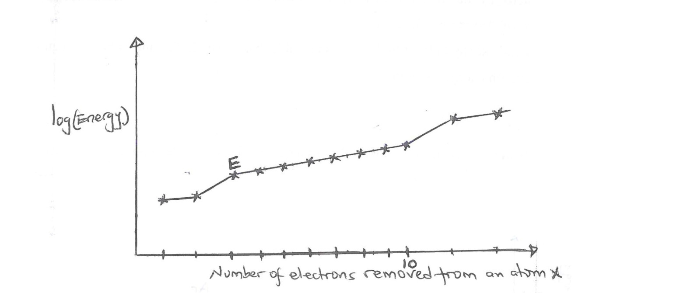
- Giving reasons state
- The group of element X
Group 2 because contains two electrons in the outer most shell i.e two electrons were removed from the outer most shell.
- The period of element X
Period 3, because the outermost electrons in quantum shell is three:
- Identify element X
Magnesium because it has 12 successive ionization energy
- Explain the sudden increase in the energy required to remove electron E
Electrons are being removed from a new shell which is closer to the nuclear (inner shell)
- Explain how the size of X will change as electrons are removed.
The size decreases because the nuclear change remains the same and the remaining electrons are strongly attracted to the nucleous and are drown closer.
- i) Explain what would be the sign of energy change if an electron was added to X to give X⁻.
Negative
- How would you expect it to affect the size of X?
The size would increase because the attraction by the nucleus on each electron is reduced.
- Explain giving reasons whether you would predict X to form compounds in the +1 Oxidation state.
It will not form compounds of oxidation state (+1) because they would be unstable.

Factors affecting ionization energy:
- Atomic radius or ionic radius
The smaller the atom, the higher the charge density and the more strongly the electrons are attracted by the nucleus increasing the ionization energy.
- Type of election configuration
Full and exactly half – filled are more stable than the underfull and therefore require more ionization energy to remove an electron.

Let us revise
The graph below shows the variation of first ionization energy with the atomic number across period 3 elements in the periodic Table.
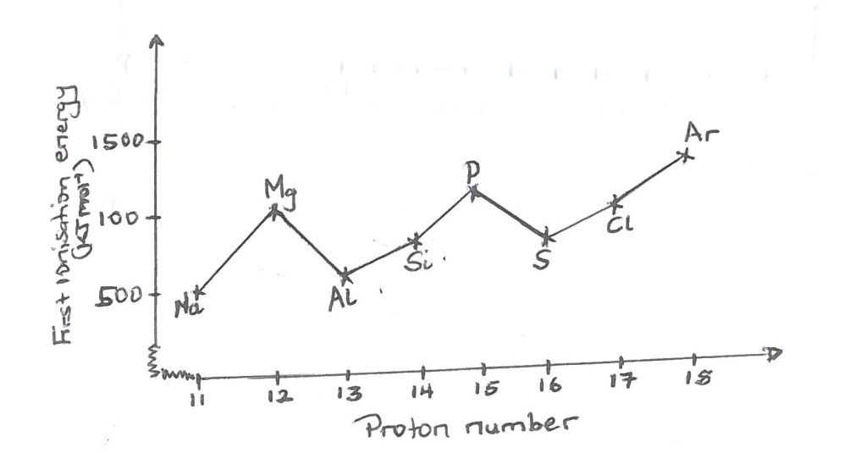

Explain why
- The first ionization energy increases over all, across the period
Across the period, there is a decrease in atomic radius and increase in nuclear charge. Both factors hence increases on attraction for the outer most electron.
- The first ionization energy of aluminium is less than that of magnesium.
₁₃Al2s²2p⁶3s²3p¹,₁₂Mg Is²2s²2p⁶3s²
Magnesium has a full 35-subshell which is stable therefore a lot of energy is required to remove an electron.
Aluminium has one electron in the 3P sub shell which is unstable hence little energy is required to an electron.
- The first ionization energy of sulphur is less than that of phosphorus
₁₅PIs²2s²2p⁶3s²3p³, ₁₆S1s²2s²2p⁶3s²3p⁴
Phosphoros has half filled 3P sub shell therefore it is stable sulphur has four electrons in the 3P sub shell therefore it is unstable.
- The first ionization energy of magnesium is very high.
₁₂Mg 1s²2s²2p⁶3s²This is because the 3s sub shell is full and therefore stable.
- Screening or shielding effect
The repulsion between the outer most electrons by the inner electrons results into an increase in atomic radius, and therefore decreases ionization energy.
The penetrating power of valency electrons in a given shell, n, decreases in the order S>P>d>f.
NOTE: Screening / shielding effect is the reduced attraction by the protons for the outer most electrons, caused by the core electrons.
Let us revise
The table below show the ionization energies inKjmol-I of five elements lettered A,B,C,
D and E.
Element | 1st I.E | 2nd I.E | 3rd I.E | 4th I.E
A | 500 | 4600 | 6900 | 9500
B | 740 | 1500 | 7700 | 10500
C | 630 | 1600 | 3000 | 4800
D | 900 | 1800 | 14800 | 21000
E | 580 | 1800 | 2700 | 11600

- Which one of these elements is most likely to form an ion with a charge of +1? Give a reason for your answer.
A, The difference between the first and second ionization energies is very high compared to the difference between the second and third ionization energies.

NOTE: take all the differences between 1st and 2nd, 2nd and 3rd and between 3rd and 4th then compare,
very high difference indicates change of energy levels.
- State i) two elements which belong to the same group in the periodic table
B and D (note)
- The group to which the element you have stated in b(i) belong
Group (II)
- i) Write the formula of the chloride of element E
EC1₃
- write equation for the reactions between the chloride of element E and water
EC1₃(s) + 3H₂O(l) E(OH)₃(aq) + 3HC1(aq)
Self check:
- The first four ionization energies of some elements are shown in the table below.
Element | Ionization energies
 | 1st | 2nd | 3rd | 4th
A | 500 | 4600 | 6900 | 9500
B | 740 | 1500 | 7700 | 10500
C | 630 | 1600 | 3000 | 4800
D | 900 | 1800 | 14800 | 2100
E | 580 | 1800 | 2700 | 11600

1) State the element that is most likely to form an ion with a unit positive change. Give a reason for your answer.

2) a) Write the electronic configuration for the following species Mg, Mg⁺, Mg²⁺, Mg³⁺
b) Which species will have the highest ionization energy and why?

Atomic and ionic radius for cations and anions
Atomic radius: is half the distance between the nuclei of any two closet atoms in a substance.
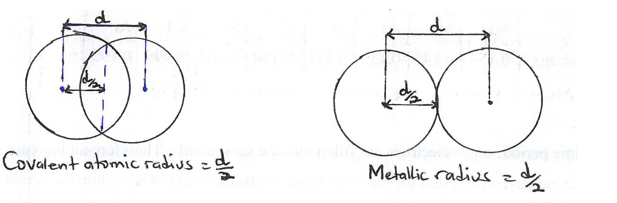
- Cations have smaller radii than the corresponding atoms
Example Na⁺ 0.018nm Na 0.157nm
This is because, the nuclear charge outsweighs the electronic charge and the remaining electrons arte more strongly attracted to the nucleus.

- Anions have a larger radii than their atoms
This is because the number of electrons exceed the number of protons, and nuclear attraction decreases on the electrons.

Trend of atomic radii of elements down the group:
Example Group (II) in the periodic table

Element | Be | Mg | Ca | Sr | Ba
Atomic radius (nm) | 0.112 | 0.160 | 0.197 | 0.215 | 0.221

Atomic radius increases down the group

Explanation:
Down the group, nuclear charge increases as protons are added to the nuclear. The screening effect / shielding effect also increases due to extra shell of electrons added, increase in screening effect out weighs increase in nuclear charge, therefore the effective nuclear charge decreases hence attraction for the outer most electrons by the nucleus decreases resulting into increase in atomic radius.

Trend of atomic radius of elements in a period
Example: Period 3
Element | Na | Mg | A1 | Si | P | S | C1 | Ar
Atomic radius(nm) | 0.154 | 0.145 | 0.130 | 0.118 | 0.110 | 0.102 | 0.099 | 0.190

Explanation:
Across the same period, outer electrons are filled into the same shells. Therefore an increase in effective nuclear charge increases attraction for the outer most electrons hence out weighing the screening effect caused by the same core electrons. Therefore as the atomic number increases the atomic radii decreases in the same period.

Let us revise
The ionic radii of Na⁺, Mg²⁺ and A1³⁺are given in the table below
Ion | Na⁺ | Mg²⁺ | A1³⁺
Ionic radius /nm | 0.095 | 0.065 | 0.050

- Briefly explain the variation in trend of ionic radii of the ions.
Solution:
As the atomic number increases, the greater the number of electrons lost from an atom, the less are the number of outer electrons to be attracted by the same number of protons, The outer most electrons are more strongly attracted and therefore, pulled nearer to the nucleus. This results in a smaller ionic radius.
- Calculate the charge / radius ratio for
- Na⁺
Charge ratio / radius = +1
0.095
= 10.526nm⁻¹
- Mg²⁺
Charge / radius ratio = +2
0.065
= 30.770nm⁻¹
- A1³⁺
Charge / radius ratio = +3
0.050
= 60.0nm⁻¹
Self check:
- The atomic numbers and the atomic radii of some transition metals are given in the table below.
Element | Si | Ti | V | Cr | Mn | Fe | Co | Ni | Cu | Zn
Atomic number | 21 | 22 | 23 | 24 | 25 | 26 | 27 | 28 | 29 | 30
Atomic radii(A⁰) | 1.44 | 1.32 | 1.22 | 1.17 | 1.17 | 1.16 | 1.66 | 1.15 | 1.17 | 1.25

- Plot a graph of atomic number versus atomic radii
- Explain the shape of your graph
- The respective atomic sizes of
- The sodium atom (Na) and the sodium ion (Na⁺) are 0.154 and 0.095nm.
- The chlorine atom (C1) and the chloride ion (C1⁻) are 0.099 and 0.181nm.
Give reasons for the differences in the sizes of the atoms and ions in each case.
- Explain why the ratio of radii Fe²⁺ is greater than 1.
Fe³⁺
Electronegativity / electropostivity
ElectronegativityIs the ability of an atom to attract electrons to itself when it is in a molecule.
Electronegativity is not an energy term and can not be measured directly.
An atom of a molecule which tends to attract more electrons to itself is described as a more electronegative atom.

- NOTE: The main factor that influences the value of electronegativity is the atomic radius of the atom. Usually the smaller the atomic radius the higher the electronegativity. Other factors includes, shielding effect, electronic configuration and charge on the atom.
- Electronegativitiy has no units.
Trends of electronegativity across a period
Example Period 2

Element | Li | Be | B | C | N | O | F | Ne
Electronegativity | 1.0 | 1.5 | 2.0 | 2.5 | 3.0 | 3.5 | 4.0 | 0

Electronegativity across a period increases
Explanation:
Across a period the atomic radius decreases, as the atomic number increases, the effective nuclear charge increases. When atoms are bonded to other atoms, their nuclei are nearer the electrons to attract them. Thus with a smaller atomic radius the attraction is greater giving the atom a higher electronegativity.

Trends of electronegativity down the group:
Example Group I
Element | H | Li | Na
Electronegativity | 2.1 | 1.0 | 0.9

Electronegativity decreases down the group
Explanation:
Down the group protons are added to the nucleus as an extra shell of electrons is also added there by increasing the atomic radius and the ability to attract bonded electrons is reduced. Electronegativity therefore decreases down the same group.

Check:
In water, oxygen has a higher electronegativity than hydrogen although it has a larger atomic radius. Therefore it pulls the electrons in the bond nearer to itself.

NOTE: In simple molecules the atom with a higher electronegativity has a negative oxidation state, and the less electronegative, a positive oxidation state. Example in carbondioxide Co₂, Oxygen is more electronegative than carbon so oxygen has -2 and carbon +4.
Self check:
- Predict, with reasons, whether a magnesium atom (Mg) will have a smaller elctronegativity than a sodium atom (Na).
Electron affinity
Is the energy lost or gained when one mole of the gaseous atoms add on one mole of electrons to form one mole of singly charged anion at 25⁰C and 1 atmosphere.

Example; C1 (g) + e C1⁻(g)
It is measured in units of KJmol⁻¹.
Atoms add on electrons to achieve the stable inert gas configuration. The more negative the electron affinity the more stable the anion formed. Generally, non-metals have a high negative electron affinity whilst metals have positive or low negative electron affinity. This indicates that metals can add electrons to their outer shell only with difficulty.
Normally anions of metals are not formed.

Factors that influences electron affinity:
- Atomic radius
- Stability of electronic configuration
- Charge carried by the anion.
Trends of electron affinity down the group:
Example Group VII
Element | F | C1 | Br | I
First electron affinities | -333 | -348 | -325 | -297

Generally electron affinity decreases down the group.
Explanation:
Down a group, atomic radius increases and electron affinity decreases. This is because less energy is released when an electron is added.

The unexpected lower negative electron affinity of fluorine is caused by its very small size. The very small size creates a very strong repulsive field for any incoming electron.
The electron has to be forced into the outer shell of the atom against this strong repulsive force. The energy used for this reduces the energy released when the electron is added to an atom. The extent of reduction is far greater than for any of the other group VII elements. The net effect is that it reduces the energy released to be lower, negative figure of -333KJMol⁻¹ compared with the nearest atom chlorine with -348KJMo⁻¹.

Trends of electron affinity across a period
Example: Period 2

Element | Li | Be | B | C | N | O | F | Ne
Electron affinity | -57 | +68 | -15 | -123 | -31 | -141 | -333 | +99

Generally electron affinity increases across a period.

Explanation:
Electron affinity increases because effective nuclear charge increases and attraction for the added electron increases. More energy is released.

The unexpected lower negative electron affinity of Boron and nitrogen values are due to the less stability of the electronic configurations of Boron and Nitrogen that is,
₅B 1s²2s²2p^{1 ,} ₇N1s²2s²2p³
Boron has the other 2P¹ which is under half filled and less stable and therefore less energy is released when an electron is added compared to Nitrogen with 2p which is half filled.

Then unexpected high positive electron affinity of Beryllium Neon values are due to more stable electron configurations of Beryllium and Neon which are fully filled and therefore more energy is released when an electron is added compared to other elements in the period. That is,
₄Be 1s²2s^{2 ,} ₁₀Ne1s²2s²2p⁶

NOTE: The first electron affinity formost elements has a negative sign (for electronegative sets) and therefore it is an exothermic change. This is because more energy is given out than the energy needed to force an electron to the nucleus of atom.
The second electron affinity has a positive sign and therefore an endothermic change. This is because the energy used to force an electron to a gaseous ion is more than the energy realized when the nucleus attracts the electron.

Let us revise
- The first electron affinities of group III elements are given below:

Element | 1st I.E (KJMol-1)
F | -328
C1 | -349
Br | -325
I | -295

a) state how the first electron affinities of the elements generally vary.
The first electron affinity decrease down the group as the atomic radius increases because less energy is released when an electron is added.

b) Explain why the first electron affinities of the elements have negative signs.
Because the energy required to force an electron to the atom is smaller than that given out when an electron is attracted by the atom.
- Give a reason (s) for the abnormally low value of electron affinity of fluorine.

Because it has a very small size and has a very high charge density.
- The table below shows the atomic numbers of some elements and their electron affinities.
Atom number | 11 | 12 | 13 | 14 | 15 | 16 | 17
Electron affinity9KJMol-1 | 2.0 | -6.7 | -3.0 | 13.5 | 6.0 | 20.0 | 36.4

- Draw a graph of electron affinity versus atomic number
- Explain the shape of the graph
Solution:
- Good student (draw a graph)
- Explanation:
There is general increase in electron affinity with increase in atomic number. The electron affinities of elements with atomic numbers 12 and 15 are lower than expected due to their electronic configuration. That is, element with atomic number 12, electronic configuration 1S²25²2P⁶ 35²hasa full sub energy level while element with atomic number 15, electronic configuration 1S²25²2P⁶ 35²3P³ has a half filled sub energy level, thus the two elements therefore resist the addition of an electron hence less energy is released.

Self check: Explain the difference between electronegativity and electron affinity.

- The first ionization energies and first electron affinities of group VII elements are given in the table below.
Element | First Ionisation energy (KJmol⁻¹) | first electron affinity (KJmol⁻¹)
Fluorine  Chlorine  Bromine  Iodine | 1681  1250  1139  1007 | -328  -349  -325  -295

- State how the first electron affinities of the elements generally vary with their first ionization energies.
- Explain why the first electron affinities of these elements have negative signs.
Other physical properties:
- Melting point and boiling point
- Solubility in water
- Structure and bonding
- Electrical conductivity

These properties unlike the previous ones (ionization energy, atomic radius, electronegativity, electroproductivity and electro affinity) do take place in bulk of atoms.
The first two factors can be explained in terms of structure and bonding.

Structure and bonding:
BONDING:
Atoms react or combined with one another by either losing, gaining or sharing of pair of electrons to attain an inert gas structure. Only electrons in the valency energy level are involved in bonding.

TYPES OF BONDING:
- Ionic bonding or electrovalent bond:
Formed by complete transfer of electron(s) from one atom to another giving rise to positively charged ions that are held together by electrostatic attraction.
Its formed between atoms of very different electronegativity values. That is, between a metal and a non –metal.
Example:Ionic bonding in sodium chloride.
\
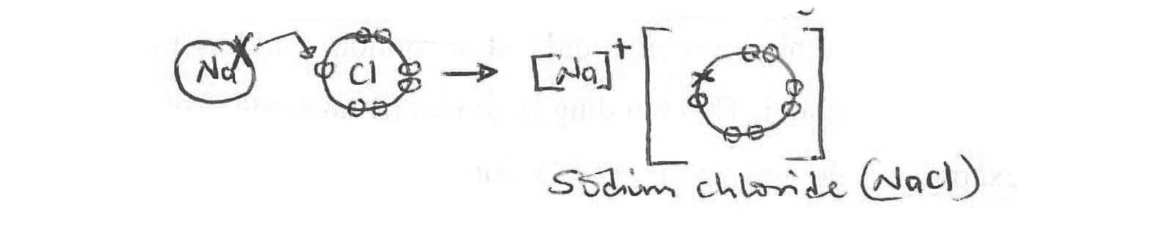
Other examples
- Magnesium oxide.
- Calcium oxide.
- Calcium chloride.
- Magnesium chloride.

NOTE: They have high lattice energy
Properties:
- They are normally hard solids
- They have high melting and boiling points due to strong electrostatic attraction.
- They are very soluble in polar solvents like water because water molecules are able to bond with both the positive and negative ions which breaks up the lattice and keeps the ions apart.
- They cannot conduct electricity when solid because the ions are not free to move but they conduct in molten state or in aqueous solution.

- Covalent Bonding
Formed by sharing a pair of electrons in a molecular orbital where each atom donates an electron
to form a molecule.
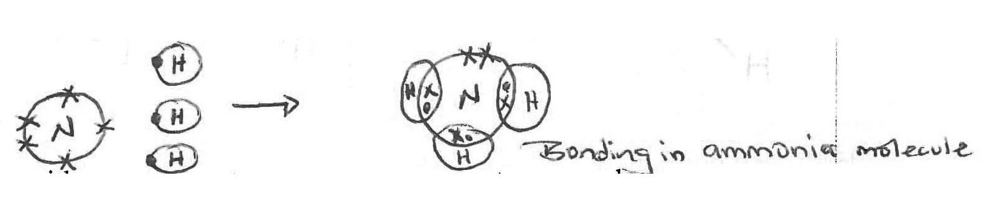
Formed between atoms with similar electronegativities hence the shared pair of electrons in the bond is almost evenly distributed between the two atoms.
Other examples
- Methane.
- Water molecule.
- Carbon dioxide.
- Silcon (IV) oxide.

Properties:
- They are mainly gases, liquids and some times soft solids.
- They have low melting and boiling points because of the weak covalent bonds.
- They consist of individual molecules held together by weak vanderwaals forces.
- They are less soluble in polar solvents but more soluble in non polar solvents.
- They don’t conduct electricity due to absence of free ions.

Classification of structures containing covalent bonds in compounds
- Simple molecular structures, are simple , they have strong covalent bonds between the atomswithin a molecule (intramolecular bonds) but have bonds between the molecules (intermolecular bonds).
Example : Iodine , Methane ,Water , and ethanol.
- Giant molecular structures ,Contain many hundreds of thousands of atoms joined by strong covalent bonds.
Examples , Diamond,Graphite,Silcon (IV)oxide ,plastics(polymers such as polythene) etc.
NOTE: In some cases individual covalent bonds of a compound may be polar but overall the compound is non-polar example carbondioxide CO₂and carbon tetrachloride CC1₄.

Explanation:
In CC1₄, each carbon-chloride bond is polar but because of symmetrical distribution of chlorine atoms about the carbon atom, there is equal and opposite dipole moment in all directions so that they cancel and hence over all CC1₄ is non polar.
Therefore covalent bond is directional.

Self check.
Boron trichloride BCl₃is a non polar molecule whereas nitrogen trichloride NCl₃ is polar.

- Co-ordinate or dative bond
Formed by sharing a pair of electrons between two atoms where by any one of the bonding atoms donates the two electrons to be shared. This is possible only if the donor atom has a lone pair of electron and the recipient has an empty outer orbital. This bonding is shown by an arrow from the donor to the recipient or by partial charges example in the formation of H₃O⁺ ions, NH₄⁺ ions and other complexes.
That is,
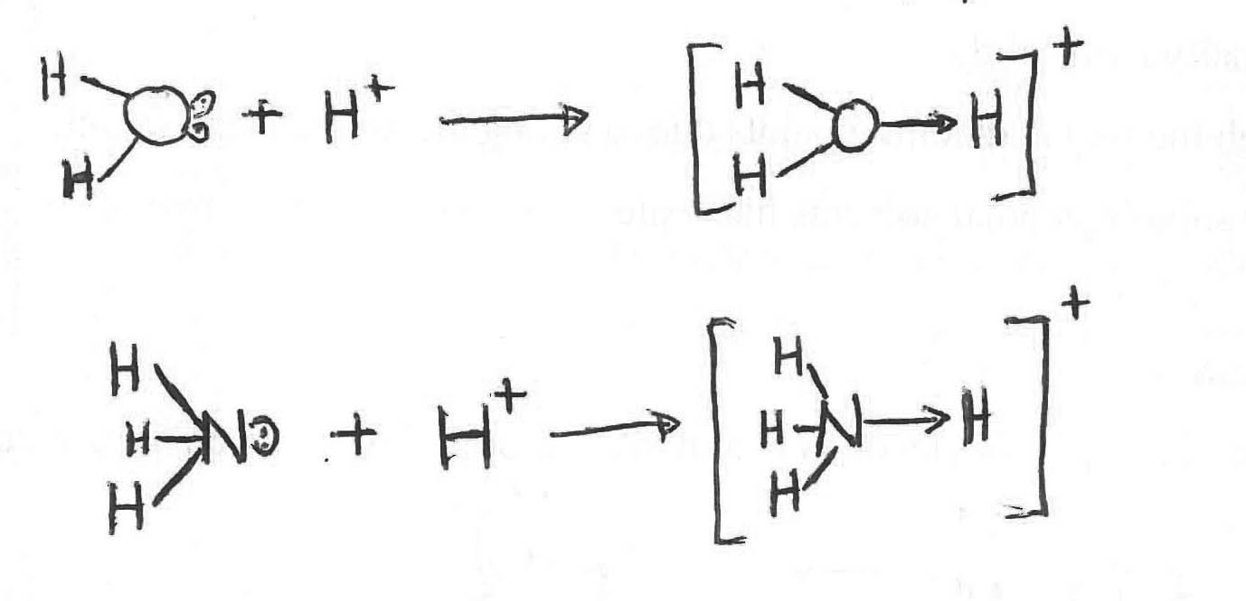
- Hydrogen bond
This is a permanent dipole-dipole attraction between a hydrogen atom bonded to an electronegative atom and to a second electronegative atom with a lone pair of electrons.
Hydrogen bonding occurs in alcohols,
R-O-H-….O-R
H
Water H-O----H----O----
H H
This bonding may occur as intermolecular hydrogen bonding when it is formed between two or more molecules.
Example in water, in 4- nitrophenol.
That is
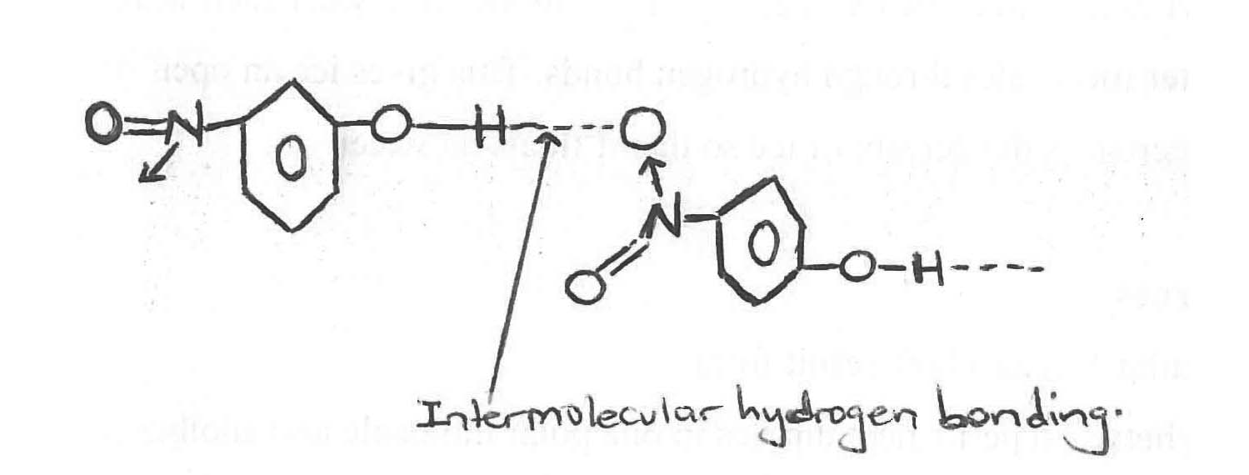
Or as intramolecular hydrogen bonding which occurs with in the same molecule in some compounds Example in 2 – nintrophenol, in 2- hydroxyl benzoic acid.
That is
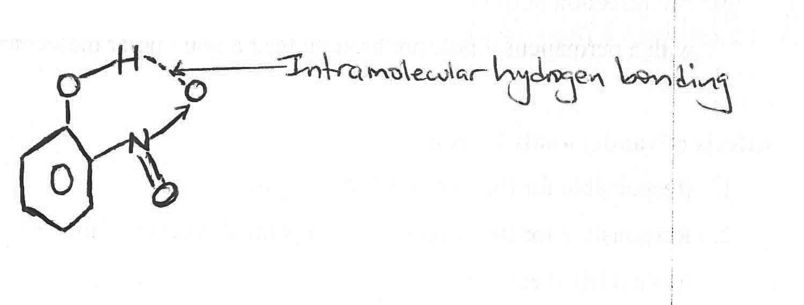
Conditions for hydrogen bonding:
- The hydrogen atom must be attracted to a highly electronegative atom which can withdraw the bonding electrons towards itself, in order for partial charges to be formed that can lead to some kind of a weak electrostatic attraction.
- The electronegative atom must have alone pair of electrons.

Effects of hydrogen bonding on properties of compounds
Hydrogen bonding only affects the physical properties.
- Increased boiling and melting point:
- Hydrogen bonded molecules like NH₃, H₂O, HF, alcohols, -COOH, amines have abnormally higher melting and boiling points because extra energy is first needed to break the hydrogen bonds before individual molecules can vapourise.

Other effects includes:- b) association of molecules
- Increased viscosity which reduces the volativity and vapour pressure .
d) increased solubility in water
e) Increased volume and decreased density of ice. In the ice crystal each water molecule is bonded to 4 other water molecules through hydrogen bonds. This gives ice an open structure with a larger volume but decreases the density of ice so that it floats on water.
5. Vanderwaals forces
These are intermolecular forces which result from
- An attraction between permanent dipoles in one polar molecule and another permanent dipole in the other polar molecule.
- An attraction between a permanent dipole and an induced dipole. This occurs when molecules with a permanent dipole are brought near a non –polar molecule.
Effects of vanderwaals forces:
- Responsible for the non-ideal of real gases.
- Responsible for the spaces between parallel layers and the sliding of these layers of graphite since it is a fairly weak force.
- It increases the strength of non-polar polymers like polythene and polypropene.
- It leads to increase in boiling points of alkanes with increasing molecular masses along the series.

STRUCTURE OF SOLIDS
Summary of the common type of structure and type of bonds adopted by elements and some compounds.
Type of structure | Type of bond | example | Melting point
Giant metallic | Attraction between nucleus and valency electrons (metallic bond) | Na, Mg, Al | Moderate
Simple molecular | - Convalent bond between atoms | Co₂, PH₃, NO₂ | Lower
 | - Vanderwaals forces between molecules | I₂, HC1, HBr | Lower
 | - Hydrogen bonds between molecules | NH₃, H₂O, HF, CH₃ CH₂OH, 4 - nitrophenol | Lower
Giant ionic | Electrostatic attraction between ions of opposite charge (ionic bond) | NaC1, Cuso₄, A₂O₃, A1C1₃, Compounds only | High
Giant covalent | Covalent bond between atoms. | SiO₂& C, Si compounds | Very high

- Giant metallic structure:
Each nucleus that is positively charged is (surrounded) attracted by the delocolised valency electrons hence metallic bond.
That is,
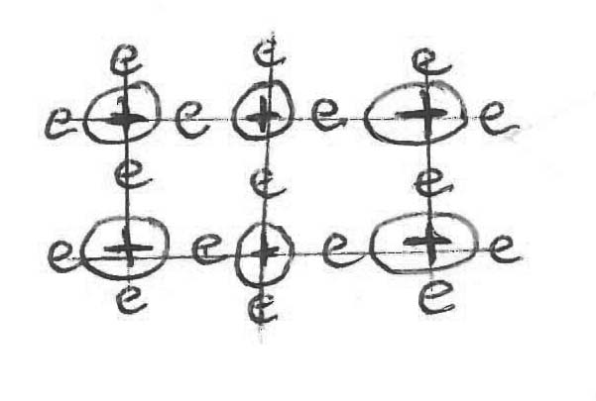
Factors affecting metallic bonds:
There are two factors
- Number of valency electrons
The more the number of valency electrons, the more attraction between the nucleus and valency electrons and the stronger the metallic bond formed.
- Atomic radius;
The smaller the atomic radius, the more attraction between the nucleus and valency electrons and the stronger the metallic bond.
- Giant ionic lattice
This consists of a regular arrangement of positive and negative ions held together by strong electrostatic attractions which are arranged repeatedly in a 3- dimensional lattice.
Example NaC1, where each Na⁺ is surrounded by 6 equidistant C1⁻ and so is C1⁻ surrounded by 6 equidistant Na+ making a co-ordination number in NaC1 structure to be 6.
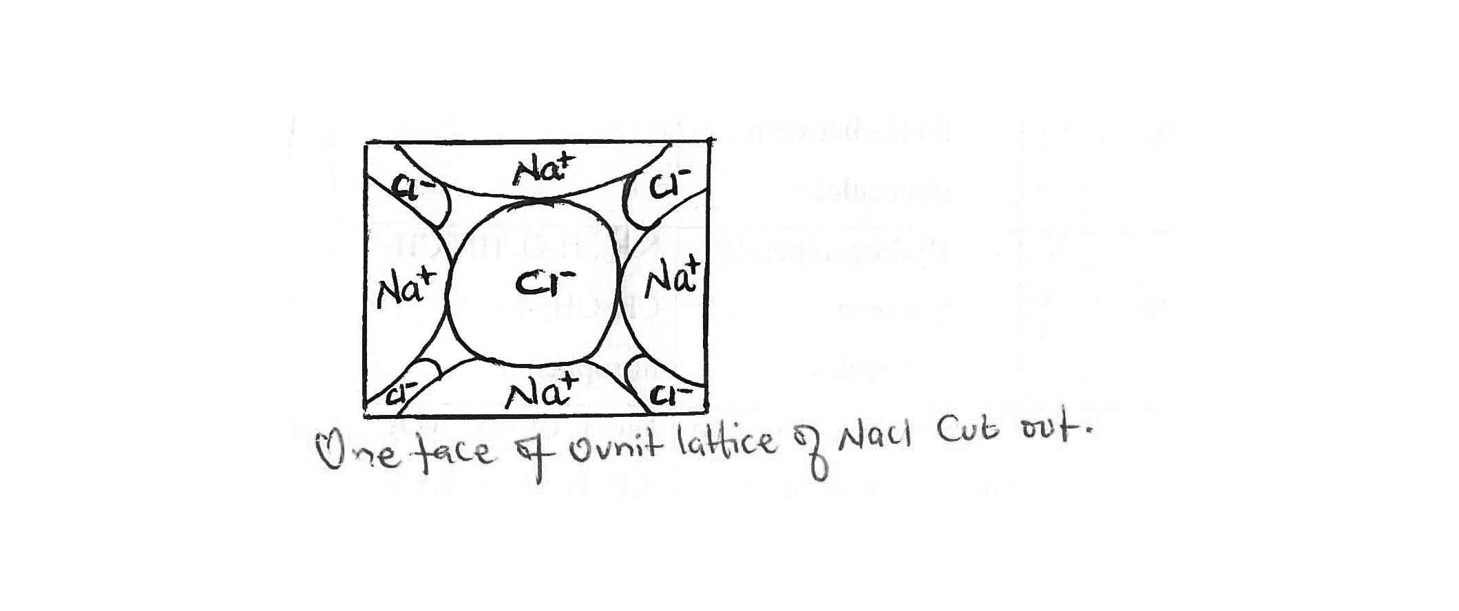
Example
Group I halides, however CsC1 structure, the co-ordination number is eight because Cs⁺ ion is larger in size than Na⁺ there can accommodate more C1⁻ ions a unit cell than Na⁺.

- Giant atomic (covalent ) lattice
In this structure, the solid is made of atoms that are covalently bonded together.
- Graphite
It is hexagonal shaped with layers which are held together by weak vanderwaal’s forces and as a result it is soft and slippery.
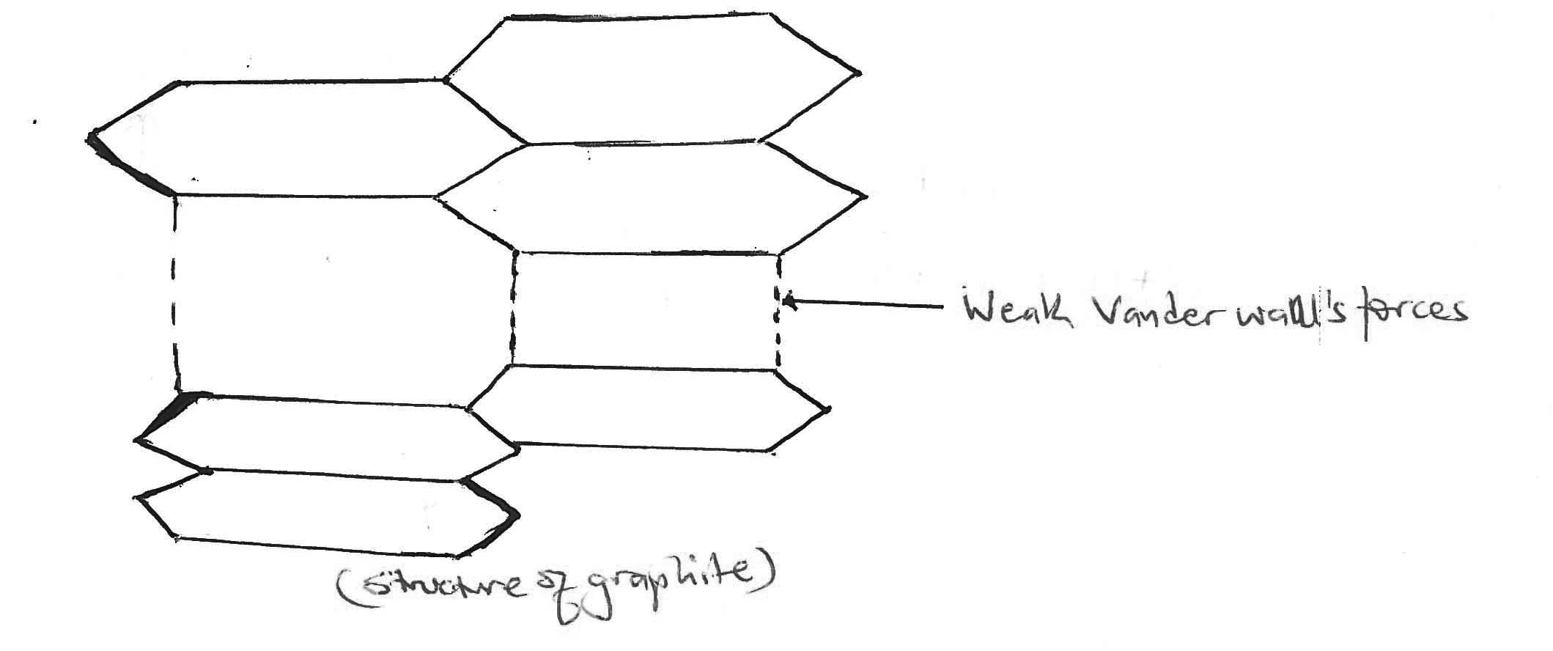
The carbon atom in graphite show a valency of 3 and not 4. The forth electron is delocalized and this explains why graphite is a conductor of electricity in solid state.

- Diamond
The atoms are in tetrahedral structure and each atom shows a valency of 4, as a result, diamond is the hardest natural substance known.

Other examples are silcon (IV) oxide
- Molecular structure
In this structure individual molecules are held together by weak vanderwaals forces. However, with in each molecule the atoms are held together by the fairly strong cavalent bonds. The weak vanderwaals forces render these covalent molecules to be gases, liquids or just soft solids with low melting points.

Example iodine I₂, carbondioxide CO₂,
That is I₂, I--I-------I--I
I ----- I

Self-check (A).
1 a)Ice has a lower density than than that of water .Explain the characteristics.
(b) Name the type of crystal lattice formed by the following subtances.
- Iodine
- Caesium chloride
- Silcon dioxide.
- Arrange the substances given in (b) in order of increasing melting point.
- Explain how the bonding in each of the compounds in (b) affect their melting points.

2.Complete the table below about the properties of different types of crystals.
Type of crystal | Force holding the crystal | Melting point,state whether low,moderate, high or very high. | Form in which electricity is conductrd if any
Metallic
Ionic
Network covalent

3.Complete the table below
Element | Formula of oxide | Oxidation of the element in the oxide | Type of bonding in the oxide | Structure of the oxide
Aluminium
Silcon
Phosphorus
Magnesium
Chlorine

4.Repeat question 3 above using formula of hydrides.

Shapes of molecules
The shape of a molecule is related to the number of electron pair in the outer most shell of the central atom.
The electron pairs repel each other so that they are as far apart as possible in order to give a molecule a very stable shape. This repulsion applies to both the bonded pairs of electrons and the lone pairs of electrons.

Steps taken:
- Identify the central atom or ion (more electronegative atom)
- Write the outer most electronic configuration of central atom.
- Work out number of bond pairs and lone pairs on central atom or molecule.
- Use the valency electron repulsion rule where electrons and lone pairs repel each other such that
Lone pair /lone pair repulsion > lone pair / bond pair repulsion > bond pair / bond pair repulsion.

Examples:
- Linear shaped molecules:
Adopted by molecules without lone pairs of electrons on a central atom. Occurs when the bonding electron pairs repel each other to attain a maximum bond angle of 180⁰,
Normally there are two bonding pairs of electrons

Example
BeCl₂

That is C1 ----Be----C1
- Carbondioxide
- Hydrogen cylinede etc

- Trigonal planar
Adopted by molecules with 3 bonded pairs of electrons but without alone pair on a central atom.
The 3 bonding pairs of electrons repel one another and attain a stable shape with a bond angle of 120⁰

Example – Boron trichloride BC1₃
₅B 2s²2p¹
2s 2p

unexcited state

Excited state

3 bond pairs
0 lone pair
Then
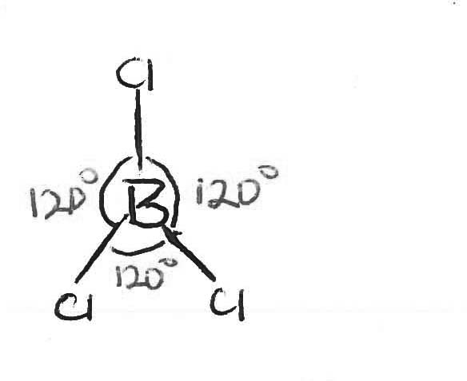

- NO₃⁻
₇N 2s²2p³
2s 2P

unexcited state

unexcited state
Note negative – gain of electron
3 bonded pairs and 0 lone pairs
Then
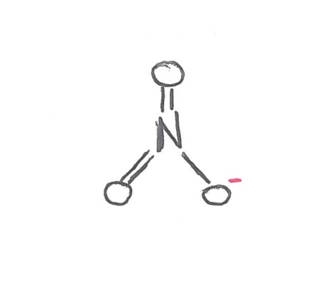
Other examples
- Boron fluoride
- Aluminium chloride
- SO₃
- CO₃²⁻
- CHOOH

- Bent (v) shaped molecules:
This may be adopted by molecules with one or two lone pair and two bonding pairs of electrons

Example water H₂O
Central atom oxygen
8^{O} 2s²2p⁴
25 2P

unexcited state
excited state

2 bond pairs
2 lone pairs
Then
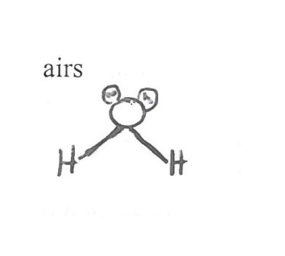
Other examples –SO₂
- SnC1₂
- H₂S
- C1₂O
- C1O₂⁻
- Pyramidal shape
This can be described as tetrahedral. It is adopted by molecules with one lone pair and 3 bonding pairs
Example
NH₃
₇N 2s²2p³
2s 2p

unexcited state

excited state

One lone pair
3 bonding pairs

Then
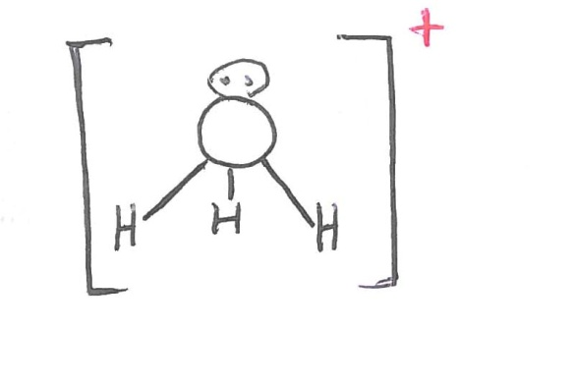
Other examples: H₃O⁺
8^{O} 2s²2p⁴
2s 2p

unexcited state

excited state

One lone pair
3 bonding pairs
Then

Others are - SO₃²⁻
- PH₃

5. Tetrahedral shape
Adopted by molecules with 4 bonding pairs of electrons without any lone pair example
SO₄²⁻
₁₆S 3s²3p⁴
3s 3p

unexcited state

excited state
One lone pair
3 bonding pairs

Then

Other examples –NH₄⁺
- CH₄
- PO₄³⁻
- SiC1₄
- C1O₄⁻

6. Trigonal Bi- Pyramidal shape
Adopted by molecules with 5 bonding pairs of electrons or 4 bonding pairs with alone pair of electrons

Example
PC1₅
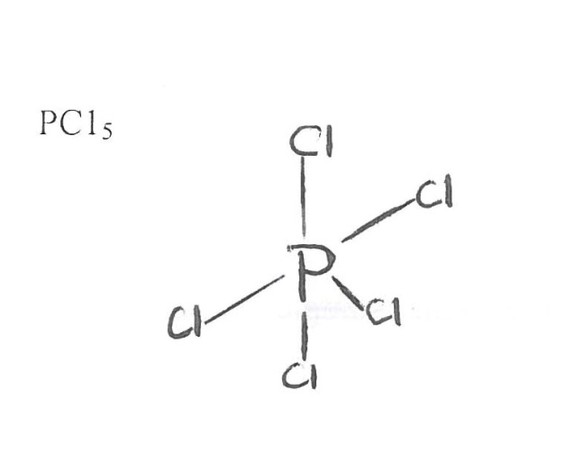
SF₄

IC1₂⁻
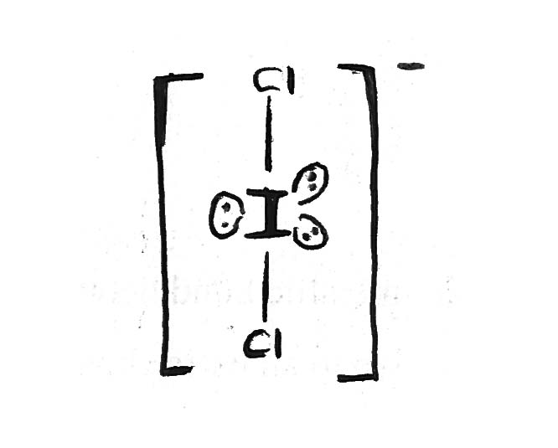
Effect of electronegativity of the central atom on bond angle:
The bond angle in the hydrides of group V is in order NH₃ > PH₃ > A₅H₃
The decrease in bond angle is due to the decreasing electronegativity of the central atoms the more electronegative the central atom is the nearer the bonding electrons are to it, this increases the concentration of electrons around the central atom and hence increased repulsion.

Self check
- Sketch the shape of the following molecules and explain why each shape adopts the shape you have sketched.
- NH₃
- BF₃
- H₂S
- The bond angle in water molecule is 104⁰ whereas that one in a molecule of ammonia is 107⁰. Explain.
Trends in structure and types of bonds of elements, chlorides and hydrides in group I, II, VII, periods and first series of transition elements of the periodic Table.
Periodic table
- Group I Li Na K Rb Cs

Type of structure Giant metallic
Type of bond metallic
Atomic radius increases
Melting points(ºc) 180 90 64 39 29

Group I Be Mg Ca Sr Ba
Type of structure Giant metallic
Type of bond metallic
Atomic radius increases
Melting points(ºc) 1280 650 850 770 700

Generally melting point decreases down the group of S – block , that is group I and group II,

Explanation:
Melting point decreases down group I and II

This is because, the element exist as a giant metallic structure with metallic bond between atoms. The strength of metallic bond decreases with increase in atomic radius due to an extra shell added.

Group II members have a higher melting point and are harder than their corresponding group (I) elements, because of
- They have a smaller atomic radius
- Have two valency electrons per atom for attraction, with the nucleus lattice for group(I) it has only one electron for valency. The larger the number of valency electrons the stronger the metallic bond.
NOTE: Melting point of group (II) are not decreasing smoothly as that of group (I) hence Mg shows abnormally low melting point.

- Group (VII) F C1 Br I
Type of structure Simple molecular
Type of bond weak vanedrwaals forces
Boiling points(ºc) -188 -34 58 185

The boiling point increases down group (VII)

Explanation:
This is because the elements exists as simple diatomic molecules with weak vander waals forces between molecules. The strength of vander waals forces increases with increases in molecular mass down the group.
- Elements of third short periods
Elements | Na | Mg | Al | Si | P | S | C1
Atomic number | 11 | 12 | 13 | 14 | 15 | 16 | 17
Melting point(ºc) | 98 | 650 | 660 | 1410 | 44 | 120 | -200

Melting point generally increases
Explanation:
From Na to Al the elements exists as giant metallic structures with the strength of metallic bond increasing with
- Decreasing atomic radius from sodium to Aluminium
- Increase in number of valency electrons from 1 to 3 respectively.

Si exists as a giant atomic structure with many covalent bonds in a tetrahedral shape holding the atoms together therefore plenty of heat at a high temperature is need to break the covalent bonds.

From phosphorous to chlorine, the elements exists as simple molecules with weak vander waals forces, the strength of vander waals forces increases with increase in molecular mass.
That is, phosphorous exists as P₄ with the structure below while sulphur exists as S₈ with the structure below.
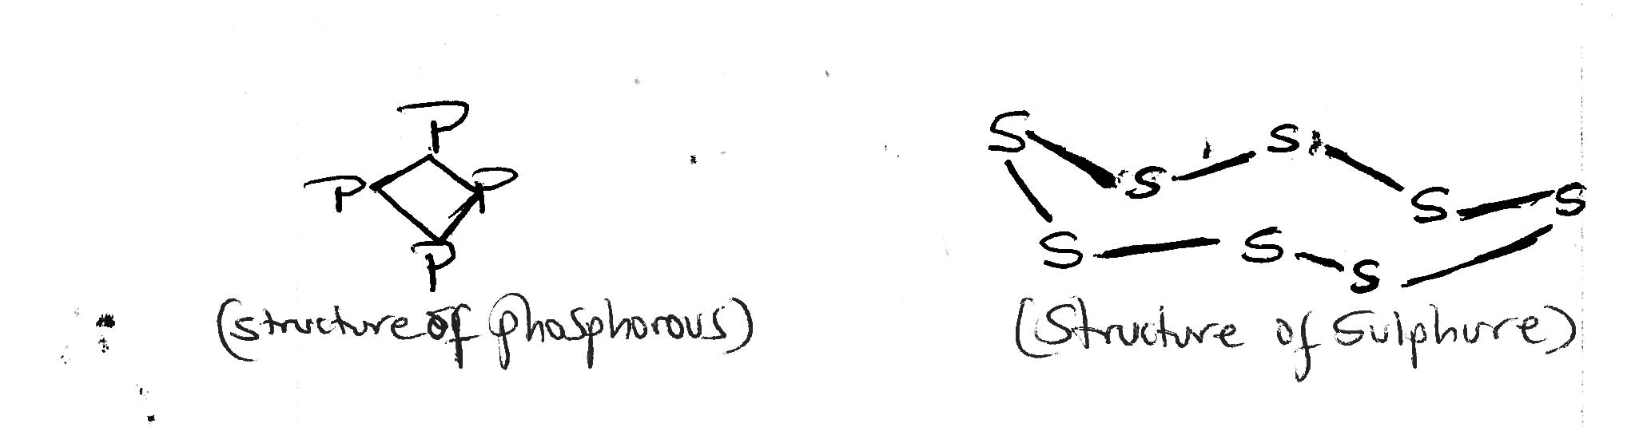
And chlorine exists as a diatomic molecule C1₂ with simple molecular structure.

- The first series of transition elements.
Element | Sc | Ti | V | Cr | Mn | Fe | Co | Ni | Cu | Zn
Atomic number | 21 | 22 | 23 | 24 | 25 | 26 | 27 | 28 | 29 | 30
Atomic radii | 0.144 | 0.132 | 0.122 | 0.117 | 0.117 | 0.116 | 0.116 | 0.115 | 0.117 | 0.125
Melting point (ºc) | 1600 | 1680 | 1917 | 1890 | 1247 | 1535 | 1490 | 1452 | 1083 | 420

Transition metals have higher melting point than the non transition metals of the same period four, that is
K, Ca, Sc, Ti, and Zn.

Explanation:
All period four elements are metals that exist as giant metallic structures with metallic bonds holding their atoms together but K and Ca have 1 and 2 valency electrons respectively used in the metallic bond while transition elements have their 3d and 4s electrons used in metallic bond. Also atomic radius decreases from K to Cu therefore as a result metallic bond strength increases with number of valency electrons and decreases in atomic radius.

NOTE: The melting point of Zn is lower than expected because of the increase in screening effect as the 3d sub shell gets filled and therefore there is an increase in atomic radius of Zn.
Physical properties of some of the compounds of elements in periodic table:
- Chlorides of third short periods

Formula of compound NaC1 Mg AlC1₃ SiC1₄ PC1₅/PC1₃
Type of structure Giant ionic simple molecular
Type of bond ionic Predominantly covalent covalent
Boiling point (ºc) 1413 1412 180 58 56
The boiling point decreases from sodium chloride to phosphorous pentachloride.

Explanation:
This is because NaC1 and Mgc1₂ exist as giant ionic structures with strong electrostatic forces between ions of opposite charge. The magnitude of ionic bond decreases with
- Decrease in cationic radius
- Charge on the ions (cation) and therefore an increases in charge density and polarizing power of the cation from Na⁺ to A1³⁺

The rest of period 3 chlorides exists as simple molecules with A1C1₃ existing as a dimer A1₂C1₆.
The molecules have weak vander waals forces between them and ionic bond are relatively stronger than weak vanderwaals forces.

b) Oxides of third short period 3
Formula of oxide | Na₂O | MgO | Al₂O₃ | SiO₂ | P₂O5 | SO3 | C1₂O₇
Atomic number | 11 | 12 | 13 | 14 | 15 | 16 | 17
Melting point (ºc) | 1275 | 2527 | 2007 | 1607 | 560 | 30 | -91
Type of structure | Giant ionic | Giant ionic | Giant ionic | Giant covalent | Simple molecular covalent between atoms and weak vander waals forces between molecules.

The melting point increases from Na₂O to MgO then reduces upto chlorine hepta oxide.

Explanation:
From Na₂O to Al₂O₃, they exist as giant ionic structure with ions of opposite charge having ionic bonds. The melting point increases from Na₂O to MgO because of increasing charge density of the cations from MgO to A1₂O₃, melting point decreases due to high charge density of Aluminium ion which makes A1₂O₃ partly covalent.
SiO₂ has a giant covalent structure with its atoms held by strong covalent bonds in a tetrahedral shape.

The rest of the oxides have simple molecular structures with its molecules held by weak vander waals forces.
The strength of vander waals forces decreases as molecular mass decreases and polarity of the molecules increase as a result of decrease in electronegativity difference with bonding atoms from P₂O₅ to C1₂O₇.

Self check:
Hydrides of period 3
Formula of hydrides | NaH | MgH₂ | A1H₃ | SiH₄ | PH₃ | H₂S | HC1
Atomic number | 11 | 12 | 13 | 14 | 15 | 16 | 17
Type of structure | Ionic |  | - | Simple molecular
Melting point (ºc) |  |  |  | 88 140 188 158

Explain the trend in melting points of the hydrides

Hint - electronegativity of the atom increases
- Polarity increases
- Intermolecular vander waals forces increases
- SiH₄ is non polar
- A1H₃ is polymeric with unknown structure.

Hydrides of group VII, VI and V
Group | Formulae
GroupVII  Boiling point | HF HC1 HBr Hi  20 -85 -67 -35
GroupVI  Boiling point | H₂O H₂S A₃H₃ H₂Te  _____________increases _________________
GroupV  Boiling point | NH₃ PH₃ A₃H₃ SbH₃  _____________________Increases __________________

With exception of hydrogen floride, which has an unexpectedly high boiling point, boiling points of group VII hydrides increases down the group.
The very high boiling point of HF is because of the relatively strong hydrogen bonding formed between molecules as a result of fluorine being the most electronegative atom in group VII.
The rest of group VII hydrides have weak vander waals forces between molecules whose strength increases with increasing molecular mass down the group.

NOTE: Some explanation is correct for group VI and V hydrides.

CHECK:
Compound M₂O₃ A1C1₃ CaO CaC1₂
Melting point 2270 451 2850 1051

Explain:
- The melting point of AlCl3 is abnormally low compared to Al₂O₃
- Themelting point of CaO is much higher than that of CaCl₂

Solution:
- Aluminium ion has a small cationic radius and a charge of +3. Aluminium ion is highly polarizing and forms predominantly covalent bonds with chlorine atom that is less electronegative than oxygen. Aluminium chloride exists as a dimer Al₂Cl₆ bond with weak vander waals forces between molecules.
Al₂O₃exists as a giant ionic structure with strong electrostatic attraction between ions of opposite charge. This is because oxygen is less polarisable than chlorine
- Oxide of CaO has a charge of -2 and chlorine has that of -1. The high charge of the oxide increases on the strength of the ionic with Ca²⁺ hence need for a higher temperature to melt the oxide compared to the chloride.

Factors that affect melting points of meatls and non-metals.
Metals – Atomic radius
- Number of valency electrons
- Charge density.
Non metal (simple molecules)
- Vander waals force
- Hydrogen bonds
- Molecular mass
Trend in solubility of group (I) and (II) hydroxides and sulphates.
All common salts of group( I) are soluble in water. The solubility of group(I) salts increases down the group, because the hydration energy and lattice energy decreases down the group but lattice energy decreases much more than the hydration energy.
Also the slat of group (II) elements are generally less soluble than those of corresponding group(I) salts. This is because, the group (II) cations have a double charge and a smaller ionic radius than their corresponding group (I) ions and therefore are more polarizing and with large lattice energy than hydration energy.
- Group (II) hydroxides
Be(OH)₂ Mg(OH)₂ Ca(OH)₂ Sr(OH)₂ Ba(OH)₂
Solubility increases
- Group sulphates
BeSO₄ MgSO₄ CaSO₄ SiSO₄ BaSO₄
Solubility increases
Explain the trends in solubility of hydroxides and sulphates of group (II).
Explanation
- Solubility increase from Beryllium hydroxide to Barium hydroxide. This is because both lattice and hydration energies decrease with increase in cationic radius, but the decrease in lattice energy is much more than the decrease in hydration energy due to the single charge on hydroxide ion involved.
- Solubility decrease from beryllium sulphate to Barium sulphate. This is because both lattice and hydration energies decreases with increase in cationic radius, but the decrease in hydration energy is much more than the decrease in lattice energy due to the double charge in sulpahte ion involved.

Chemical properties of elements, oxides, chlorides and hydrides of :
The third short period:
The reactions to be considered will be with
- Water
- Acids
- Sodium hydroxide solution
Element | Na | Mg | Al | Si | P | S | Cl | Ar
Atomic number | 11 | 12 | 13 | 14 | 15 | 16 | 17 | 18
Type of structure | Giant metallic Giant atomic simple molecular  covalent bond between atoms and  Metallic covalent weak vander waals forces  between molecules.
Type of bond

- With water
- Sodium reacts vigourosly giving sodium hydroxide and hydrogen gas.
2Na(s) + 2H₂O(s) 2NaOH(aq) + H₂(g)
- Clean magnesium reacts very slowly with cold water but when heated, it burns in steam with a white flame to give hydrogen gas.
Mg(s) + 2H₂O(i) Mg(OH)₂(aq) + H₂(g)
Mg(s) + H₂O(g) MgO(s) + H₂(g)
- Minimum doesnot react with water or steam even when heated. This is because of a thin film oxide coating formed on its surface.
(a diagonal relationship with Beryllium).
- For non metals, silcon when strongly heated reacts with steam to form silcon (IV) oxide
Si(s) + 2H₂O(g) SiO₂(s) + 2H₂(g)
(White solid)
- Phosphorous and sulphur, do not react with water.
- Chlorine reacts with cold water forming hydrochloric acid and chlorate (I) acid.
Cl₂(g) + H₂O(l) HCl(aq) + HOCl(aq)
- With Acids (HCl, H₂SO₄ and HNO₃)
- The reactions of the elements with dilute acids are the same as with water, except the reactions are more vigourous.

Example: 2Na(s) + 2HCl(aq) 2NaCl(aq) + H₂(g)
Mg(s) + H₂SO₄(aq) MgSO₄(aq) + H₂(g)
- Alminium when heated reacts with dilute sulphuric acid
2Al(s) + 3H₂SO₄(aq) Al₂(SO₄)₃(aq) + 3H₂(g)

NOTE: Aluminium does not react with HNO₃. Alminium is made passive by nitric acid, a diagonal relationship with beriyllium in group (II).
- Silicon is not attacked by any acid except hydrofluoric acid to form hexafloric acid and hydrogen.
Si(s) + 6HF(aq) H₂SiF₆(l) + 2H₂(g)
- Phosphorous and sulphur and chlorine do not react with dilute acids but concentrated nitric acid oxidizes phosphorous in presence of water to give orithophosphoroic acid, nitrogen monoxide and dioxide
- P₄(s) + 12HNO₃(aq) 4H₃PO₄(aq) + 4NO(g) + 8NO₂(g)
- Sulphur gives sulphunic acid, water and Notrogen dioxide
S(s) + 6HNO₃(l) H₂SO₄(aq) + 2H₂O(aq) +6NO₂(g)
- Concentrated sulphuric acid oxidizes sulphur to sulphur dioxide and itself is reduced to water.
S(s) + 2H₂SO₄(l) 3SO₂(g) + 2H₂O(l)

- With sodium hydroxide solution NaOH(q)
- Na and Mg do not react with sodium hydroxide because they are strongly electropositive.
- Aluminium is weakly electropositive and reacts with sodium hydroxide and water to give Aluminate ion and hydrogen gas. (a diagonal relationship with Berryllium)
2Al(s) + 2OH(q) + 6H₂O(q) 2Al(OH)₄₋ (q) + 3H₂(q)

For non metals
Silicon and phosphorous also react with sodium hydroxide and water giving SiO2 and hydrogen phosphate and phosphine gas.
Si(s) + 2OH(aq) +H₂O(l) SiO₃²⁻(aq) + 2H₂(g)
P₄(s) + 3OH(aq) + 3H₂O(l) 3H₂PO²⁻(aq) + PH₃(g)
(White)

Sulphur reacts slowly with hot concentrated sodium hydroxide to give sulphite and sulphide ions and water.
3S(s) + 6OH(Q) SO₃²⁻ (aq) + 2S²⁻ (aq) + 3H₂O(l)
With chlorine there are two different products formed depending on the concentration and temperature
- With cold dilute sodium hydroxide, chloride ions, chlorate ions and water are formed.
Cl₂(g) + 2OH(aq) Cl⁻(aq) + ClO(aq) + H₂O(l)
- With hot and concentrated alkali, chloride ions, chlorate (V) and water are formed.
3Cl₂(q) + 6OH(aq) 5Cl⁻ (aq) + ClO₃⁻(aq) + 3H₂O(l)

Oxides of period 3
Only normal oxides will be discussed. These can be divided into four depending on their behavior with water, acids and bases.
- Base
- Amphoteric
- Acidic
- Neutral

Earlier we subdivided oxides according to the type of structure and type of bonding when we considered physical properties.

Element | Na | Mg | Al | Si | P | S | Cl
Formula of oxide | Na₂O | MgO | Al₂O₃ | SiO₂ | P₂O₅ | SO₂ | Cl₂O₇
Type of structure | Giant ionic Giant ionic Giant Giant  covalent |  |  |  | Simple molecular
Type of bond | Ionic ionic ionic covalent covalent |  |  |  | Covalent bond between atoms  and weak van der waal´s between molecules
Acid base | Strongly ionic |  | Amphoteric | Weakly acid | Strongly acidic

Reactions with:
- Water
A reaction of part or all the salt derived from a weak acid or weak base with water to give corresponding base or acid usually is specifically known as hydrolysis. Hydrolysis will also be considered in physical chemistry under ionic equillibrium.
- Na₂O gives sodium hydroxide which is alkaline with PH greater than 7.
Na₂O(s) + H₂O(l) 2NaOH(aq)
Sodium hydroxide is used so much in qualitative analysis for identification of cations.
- MgO and Al₂O₃ do not react with water and are sparingly soluble in water.
- For non metals SiO₂ is insoluble in water and does not react with it.
- P₂O₅(P₄O₁₀) reacts with a hissing sound on contact with water to give tetra oxophosphoric acid (ortho phosphoric acid).
P₂O₅(s) + 3H₂O(l) 2H₂PO₄(aq)
- SO₂ forms sulphorous acid as SO3 forms sulphuric acid.
SO₂(g) + H₂O(l) H₂SO₃(aq)
SO₃(g) + H₂O(l) H₂SO₄(aq)
- Acids
- Na₂O and MgO react to form corresponding salt and water example
Na₂O(s) + 2HCl(aq) 2NaCl(aq) + H₂O(l)
MgO(s) + H₂SO₄(aq) MgSO₄(aq) + H₂O(l)
- Al₂O₃ is amphoteric and gives also a salt and water
Al₂O₃(s) + 6HCl(aq) 2AlCl₃(aq) + 3H₂O(l)
Al₂O₃+3H₂SO₄(l) Al₂(SO₄)₃(aq) + 3H₂O(l)
- SiO₂ is not attacked by any acid (just like) except hydrofluoric acid to form flourosilicic acid and water.
SiO₂(s) + 6HF(l) A₂SiF₆(aq) + H₂O(l)
- P₂O₅ is a strong dehydrated agent and dehydrates concentrated sulphuric acid and nitric acid according to the equation.
2H₂SO₄(l) + P₄O₁₀(s) 2SO₃(g) + 4HPO₃(aq)
4HNO₃(l) + P₄O₁₀(s) 2N₂O₅(s) + 4HPO₃(aq)
- The rest of the oxides SO₂, SO₃and Cl₂O₇ become more acidic to react with acids.
- Sodium hydroxide solution
- Na₂O and MgO do not react because they are strongly basic.
- Al₂O₃ reacts together with water giving aluminate ion
Al₂O₃(s) + 3H₂O(l) + 2OH(aq) 2Al(OH)₄⁻(q)
- The rest of the non metal oxides react giving the corresponding ion of the salt and water Example
SiO₂(s) + 2OH(aq) SiO₃²⁻(aq) + H₂O(l)
SiO₂(s) + 2OH9(aq) + 2H₂O(l) Si(OH)₆²⁻ (aq)
SO₂(g) + 2OH(aq) H₂O(l) + SO₃²⁻(aq)
P₂O₅(s) + 4OH(aq) 2HPO₄²⁻(aq) + H₂O(l)
SO3(g) + 2OH(aq) SO₄²⁻(aq) + H2O(l)
And Cl₂O₇(s) + 2OH(aq) 2ClO₄⁻(aq) + H₂O(l)
(Chlorate(VII) ion)
Chlorides of period 3
Element | Na | Mg | Al | Si | P | S | Cl
Formula of Chloride | NaCl | MgCl₂ | AlCl₃ | SiCl₄ | PCl₅ | S₂Cl₂ | Cl₂
Type of structure | Giant ionic Simple molecular
Type of bond | Ionic |  |  | Covalent bond between atoms and  weak vanderwaals between molecules
Acid base character | Neutral Increasing acidic character

Reactions
- With water
- Solution chloride dissolves in water to give solution with PH=7 because the salt is from a strong base and a strong acid and complete neutralization is reached.
- Magnesium chloride undergoes a little hydrolysisand the solution formed is slightly acidic and is unable to turn litmus paper to blue.
- The rest of the chlorides undergo hydrolysis giving a solution with a PHless than 7.
Example
- Aluminium ions are highly polarizing because of the small cationic radius and a high charge of +3and therefore exists in aqueous solution as [Al(HO)₆]³⁺
That is
[Al(H₂O)₆]³⁺(aq) +H₂O(l) [Al(H₂O)₅OH]²⁺(aq) + H₃O+(aq)
[AlCH₂O)₅OH]²⁺(aq) + H₂O(l) [Al(H₂O)₄(OH)₂]⁺(aq) +H₃O⁺(aq)
[Al(H₂O)₄(OH)₂]⁺(aq) + H₂O(l) [AlCH₂O)₃(OH)₃](s) + H₃O⁺(aq)
Over all:
[Al(H₂O)₆]³⁺(aq) + 3H₂O(l) [Al(H₂O)₃ (OH)₃](s) + 3H₃O⁺(aq)
Observation:
A whiteprecipitate of aluminium hydroxide[AlCH₂O)₃(OH)(aq)is formed and because of this hydrolysis reaction, Aluminium carbonate is never formed in aqueous solution .

NOTE: Other ions that show similar properties with Al³⁺ are Fe³⁺ and Cr³⁺ ions.
Observation:
Fe³⁺ gives a brown precipitate
Cr³⁺ gives a green precipitate
- SiCl₄(l) + 4H₂O(l) Si(OH)4(aq) + 4HCl(aq)
- PCl₃(l) + 3H₂O(l) H₃PO₃(aq) + 3HCl(aq)
- Cl₂(g) + H₂O(l) HOCl(aq) + HCl(aq)
Check:
Explain what would be observed if
- Sodium carbonate solution was added to concentrated solution of aluminium chloride.
- Magnesium ribbon is added to concentrated solution of Aluminium chloride.
Solution:
- [Al(H₂O)₆]³⁺(aq) +H₂O(l) [Al(H₂O)₅OH]³⁺(q) + H₃O+(q)
Then 2H₃O⁺(aq) + CO₃²⁻(aq) 3H₂O(l) + CO₂(g)

Observation:
Bubbles of a colourless gas that turns wet blue litmus paper red and lime water milky.
- Then
Mg(s) + 2H₃O⁺(g) Mg(OH)₂(aq) + 2H₂(g)
Observation
Bubbles of a colourless gas hat gives a pop sound with a burning splint.

Self check:
State what would be observed and write equation for the reaction when
- A solution of potassium carbonate is added to aqueous aluminum nitrate.
- Solid potassium iodide is heated with concentrated sulphuric acid.

Period 3 hydrides
Element | Na | Mg | Al | Si | P | S | Cl
Formula | NaH | MgH₂ | (AlH₃)x | SiH₄ | PH₃ | H₂S | HCl
Type of structure | Giant ionic Simple molecular

Reactions:
- With water
- NaH and MgH₂ react with water and resultant solution turns litmus blue.
NaH(s) + 2H₂O(l) NaOH(aq) + 2H₂(g)
MgH₂(s) + 2H₂O(l) Mg(OH)₂(S) + 2H₂(g)
(White)
- SiH₄ and PH₃ do not react with water but SiH₄ hydrolyses when a little alkali is present
SiH₄(s) + 4H₂O(l) + 2OH(aq) Si(OH)₆²⁻(aq) + 4H₂(g)
- Phosphine PH₃ does not react or dissolve in water.
- The rest of hydrides H₂S and HCl dissolve in water to give solution of PH less than 7
H₂S(g) + H₂O(s) HS(aq) + H₃O⁺(aq)
HCl(g) + H₂O(l) Cl⁻(q) + H₃O⁺(aq)

S. Block elements and some compounds the elements from:
a) consists of group (I) also known as alkaline metals and group (II) known as alkaline earth metals.
b) the general outer most electron configuration for group (I) is ns¹ and for group (II) is ns².

These elements are in s-block because their outer most electrons are in s-subshell.
Group( I) shows an oxidation state of +1 while group (II) shows +2.
- All s-block elements are metals with metallic character increasing with increase in atomic radius down the group. Therefore group (I) elements are more electropositive than the corresponding group II elements.

Group (I) | Li | Na | K | Rb | Cs
Group (II) | Be | Mg | Ca | Sr | Ba
Group (III) | B | Al | Ga | In | Tl

CHAEMICAL PROPERTIES OF S-BLOCK ELEMENTS WITH
- Water (b) mineral acids (c) sodium hydroxide (d) non metals.
- Water
All s-block elements react with water except Berryllium (diagonal relationship of Berryllium and aluminium).
This is because of a thin film n oxide coating formed on the surface of metal which protect it from reacting.
The vigour in reaction increases with increase in atomic radius down the group.
- Lithium reacts with water slowly and vigorously sodium metal and violently with potassium giving a purple flame.
2Li(s) + 2H₂O(l) 2LiOH(aq) +H₂(g)
2Na(s) + 2H₂O(l) 2NaOH(aq) +H₂(g)
2H(s) + 2H₂O(l) 2KOH(aq) +H₂(aq)

- Berryllium does not react with water or steam even when heated, magnesium reacts slowly with cold water giving Magnesium hydroxide and hydrogen gas. But vigorous with steam giving Magnesium oxide and water.
Mg(s) + 2H₂O(s) Mg(OH)₂(s) +H₂(g)
Mg(s) + H₂O(g) MgO(s) +H₂(g)

Calcium reacts steadly with cold water but Barium is the most vigorous of all.
Ca(s) + H₂O(l) Ca(OH)₂(s) +H₂(g)
Ba(s) + H₂O(l) Ba(OH)₂(aq) +H₂(g)

NOTE; that the resultant solution turns litmus paper to blue.
- With mineral acids (HNO₃, HCl, H₂SO₄)
- All s-block elements react with dilute mineral acids except beryllium which is rendered passive by nitric acid. (A diagonal relationship of beryllium and Aluminium).
Beryllium reacts with other mineral acids after warming and the reactions are similar with those of water except that they are more vigorous

Example:
2Na(s) + 2HCl(aq) 2NaCl(q) +H₂(g)
Be(s) + 2HCl(aq) Warm) BeCl₂(aq) +H₂(g)

Mg(s) + HCl(aq) MgCl₂(aq) +H₂(g)
Be(s) + H₂SO₄(aq) BeSO₄(aq) +H₂O(l)
Mg(s) + H₂SO₄(aq) MgSO₄(aq) +H₂O(l)
Ca(s) + H₂SO₄(aq) CaSO₄(aq) +H₂O(l)

(ii)Barium reacts with dilute sulphuric acid only after warming because solubility of group (II) sulphates decreases down the group. Ba(s) + H₂SO₄(q) warmBaSO₄(s) +H₂(g).

(iii)With concentrated sulphuric acid and concentrated nitric acid
Berryllium reacts with hot concentrated sulphuric acid giving beryllium sulphate as sulphuric acid is reduced to water and sulphurdioxide.
Be(s) + 2H₂SO₄(l) BeSO₄(aq) +2H₂O(q) + SO₂(g)

A similar reaction occurs with magnesium.
Mg(s) + 2H₂SO₄(l) MgSO₄(aq) +2H₂O(l) + SO₂(g)
Hot concentrated Nitric acid reacts with Magnesium giving magnesium nitrate as nitric acid is reduced to water and nitrogen monoxide.
3Mg(s), + 8HNO₃(l) 3Mg(NO₃)₂(aq) + 4H₂O(l) + 2NO(g)

- Alkali (sodium hydroxide)
All s-block elements don’t react with sodium hydroxide solution except beryllium because it is weakly electropositive and reacts in presence of water to give berryllateion and hydrogen gas.
Be(s) + 2OH_{(aq)} + 2H₂O(l) Be(OH)₄²⁻ _{(aq)} + H₂(g)

- With other non-metal elements
- With oxygen and chlorine, all s-block elements when heated react with oxygen to form normal ionic oxides except beryllium oxide which is predominantly covalent and an amphoteric oxide (diagonal relationship of beryllium and aluminium).

4Li(s) + O₂(g) 2Li₂O(s)
2Na(s) +O₂(g) Na₂O(s)
2Be(s) +O₂(g) 2BeO(s)

NOTE: with chlorine they form the corresponding chlorides.(Write equations for the equation).
- With Nitrogen
Lithium like magnesium burns in nitrogen to form a nitride.
6Li(s) + N₂(g) 2Li₃N(s)
On hydrolysis magnesium nitride Mg₃N₂gives magnesium hydroxide and ammonia.
Mg₃N₂(s) + 6H₂O(l) 3Mg(OH)₂(s) +2NH₃(g)
Observation
A colorless gas that turns red litmus paper blue and a colourless solution that turns red litmus paper blue

Other group (II) elements don’t react with nitrogen gas even when heated.
- With carbon
Group II element when heated react with carbon to form carbides of general formula MC₂ example
Calcium carbide CaC₂ except beryllium which forms Berryllium carbide of formula Be₂C and on hydrolysis beryllium carbide gives methane ( a diagonal relationship of beryllium and aluminium).
Other group (II) carbides form ethyne on hydrolysis
That is
Be₂C(s) + 4H₂O(l) 2Be(OH)₂(s) +CH₄(g)
And
Al₄C₃(s) + 12H₂O(l) 4Al(OH)₃(s) +3CH₄(g)

AlsoCaC₂(s) + 2H₂O(l) Ca(OH)₂(s) +C₂H₂(g)

THE DIAGONAL RELATIONSHIP

Group I II III IV
Period 2 Li Be B C
3 Na Mg Al Si
On moving from left to right across the period in the periodic table the electronegativity increases while on moving down the group the electronegativity decreases. Hence elements in period 3 diagonally to the right of those in period 2 have similar electronegativity and similar poralising power and they show similar properties.

A summary of similarity in which
- Lithium in group (I) resembles Magnesium in group (II) and differences from other group (I)
element.
That is Na, K, Rb, and Cs
Similarities | Differences
- Both burn in nitrogen to give nitrides. That is 6Li(s) + N₂(g) 2Li₂N(s)  3Mg(s) + N₂(g) Mg₃ N₂(s)  (White solid) | No reaction
- Burn in oxygen to form monoxides only.  2Mg(s) + O₂(g) 2MgO(s)  2Li(s) + O₂(g) Li₂O(s) | Burn to form peroxide in addition to monoxide
- Their hydrogen carbonate exist in solution | Hydrogen carbonates exist in solid state.
- Their carbonates decompose on heating | Donot decompose on heating
- Their nitrates decompose when heated to give nitrogendioxide NO₂ and oxygen O₂ | Decompose to give nitrites and oxygen.
- Their halides with exception of fluoride are soluble in ethanol and other organic solvent | Corresponding halides are much less soluble.

- Beryllium in group(II) resemble aluminium in group III and differs from other group II.
Similarities | Differences
- Both do not react with water even when heated | They react
- Bothe are rendered passive by nitric acid | They react
- Bothe react with sodium hydroxide solution in the presence of water to give Aluminate and Berryllate.  Be(s)+2OH(aq) + 2H₂O(s) Be(OH)₄²⁻(aq) + 3H₂(g)  2Al(s)+2OH(aq) + 6H₂O(l) 2A(OH)₄⁻(aq) + 3H₂(g) | They do not react because they are strongly electropositive.
- The elements form oxides and hydroxides which are Amphoteric | Form basic oxides whose basicity increase with increase in cationic radius
- Their carbides hydrorise to give methane | Their carbides hydrorise to give ethyne. That is  CaC₂(s)+H₂O(l) Ca(OH)₂(s)+C₂H₂
- Berryllium carbide and Alminium carbide exists as dimmers. That is; | No dimmers
- Beryllium chloride and Alminium chloride in hydrorise water giving a solution that turns blue litmus paper red. | No hydrolysis.

- Boron in group (III) resembles silcon in group (IV) and differs from other group (III) elements.
Similarities | Differences
- Both are non metals and non conductors of electricity | They are metals and good conductors of electricity.
- Their chlorides are soluble in organic solvents and readily hydrorised | Insoluble
- Their hydrides easily catch fire in air at room temperature | Are spontaneously inflammable.
- Their oxides B₂O₃ (diborontrioxide) and SiO₂ are weakly acid. | Al₂O₃ is amphoteric

Some important uses of group (I) hydroxides and sodium thiosulphate (Na₂S₂O₃.2H₂O)
- Sodium hydroxide solution and aqueous Ammonia is used in quantitative analysis to identify the cations. Each is added to a little of the solution of an unknown until in excess.

TEST | OBSERVATION | DEDUCTION
- Add sodium hydroxide solution until in excess | - White precipitate insoluble in excess  - White precipitate soluble in excess giving a colourless solution  - White precipitate turns pink then brown, insoluble in excess.  - Dirty green precipitate insoluble in excess.  - Brown precipitate insoluble in excess.  - Blue precipitate insoluble in excess  - Grey green precipitate insoluble in excess  - Grey green precipitate soluble in excess giving a green solution  - A blue – green precipitate turns pink and then brown, insoluble in excess. | Mg²⁺, Ca²⁺, Ba²⁺  Al³⁺, Zn²⁺, Pb²⁺  Mn²⁺  Fe²⁺  Fe³⁺  Cu²⁺  Ni²⁺  Cr³⁺  Co²⁺

Add aqueous ammonia until in excess | (a)White precipitate insoluble in excess | Mg²⁺,Al³⁺,Pb²⁺
 | (b)White precipitate soluble in excess giving a colourless solution | Zn²⁺.
 | (c)White precipitate turns pink then brown, insoluble in excess. | Mn²⁺
 | (d)Dirty green precipitate insoluble in excess slowly turns brown. | Fe²⁺
 | (e)Brown precipitate insoluble in excess | Fe³⁺
 | (f)Blue precipitate soluble in excess giving a blue solution.  (g)A green precipitate soluble in excess giving a blue solution. | Cu²⁺  Ni²⁺
 | (h)Grey green precipitate soluble in excess giving a pink solution | Cr³⁺
 | (i)Blue precipitate soluble in excess giving a red solution. | Co²⁺
 | (j)No observable change | Ba²⁺ , Ca²⁺

NB: The precipitates are formed because of the insoluble hydroxides of the respective metal salts formed and ones which dissolve in colourless due to complex. These reactions can be used to identify the cation(s).

Equation of the table involving aqueous Ammonia and sodium hydroxide solution.

Mg²⁺(aq) + 2OH(aq) Mg(OH)(s)
Ca²⁺(aq) + 2OH(aq) Ca(OH)₂(s)
Ba²⁺(aq) + 2OH(aq) Ba(OH)₂(s) white precipitate
Al³⁺(aq) + 3OH(aq) Al(OH)₃(s)
Pb²⁺(aq) + 2OH(aq) Pb(OH)₂(s)
Zn²⁺(aq) + 2OH(aq) Zn(OH)₂(s)

In sodium hydroxide there is no reaction with,Ba²⁺and Ca²⁺ because the concentration of Hydroxide IonS from Ammonia solution is very low so that it is insufficient fo Ksp for Ba(OH)₂ and Ca(OH)₂ to be reduced. But in excess sodium hydroxide solution only.
Al³⁺, Zn²⁺ andPb²⁺hydroxides dissolves to form complexes

Zn(OH)₂(s) + 2OH(aq) Zn(OH)₄²⁻(aq)
Al(OH)₃(s) + OH(aq) Al(OH)₄⁻(aq) colourless solutions
Pb(OH)₂(s) + 2OH(aq) Pb(OH)₄²⁻(aq)

However in excess aqueous Ammonia only Zinc hydroxide dissolves.
Zn(OH)₂(s) + 4NH₃(aq) Zn(NH₃)₄2OH(aq) Colouless solution

c) in both sodium hydroxide and Ammonia solution
Mn²⁺(aq) + 2OH(aq) Mn(OH)₂(s)

Turning brown is due to hydrated manganese (IV) oxide formed by oxidation of Mn(OH)₂. That is,
2Mn(OH)₂(s) + O₂(g) 2MnO₂H₂O(s)
White ( Brown)

In both sodium hydroxide and Ammonia solution
(d) Fe²⁺(aq) + 2OH(aq) Fe(OH)₂(s)
(Dirty green precipitate)
- In both, Fe³⁺(aq) + 3OH(aq) Fe(OH)₃(s)
( Brown precipitate)

- Cu²⁺(aq) + 2OH(aq) Cu(OH)₂(s)
(Blue precipitate)
The blue precipitate on heating forms a black solid of copper(II) oxide, that is,
Cu(OH)₂(s) CuO(s) + H₂O(l).

However in excess, aqueous Ammonia the blue precipitate dissolves giving a deep blue solution. That is,
Cu(OH)₂(s) + 4NH₃(aq) Cu(NH₃)₄²⁺(aq) + 2OH(aq)
(Deep blue solution)

- Ni²⁺(aq) + 2OH(aq) Ni(OH)₂(s)
(Green precipitate)
However in excess aqueous Ammonia the precipitate dissolves giving a blue solution.
Ni(OH)₂(s) + 6NH₃(aq) Ni(NH₃)₆²⁺(aq) + 2OH(aq)
- Cr³⁺(aq) + 3OH(aq) Cr(OH)₃(s)
(Grey –green precipitate)

- In excess sodium hydroxide solution the precipitate dissolves giving a green solution.
That is, Cr(OH)₃(s) + 3OH(aq) Cr(OH)₆³⁻(aq)
Green solution
And in excess aqueous Ammonia the precipitate dissolves giving a pink solution. That is
Cr(OH)₃(s) + 6NH₃(aq) Cr(NH₃)₆³⁺(aq) + 3OH(aq)
c) Co²⁺(aq) + 2OH(aq) Co(OH)₂(s)
(blue precipitate)
however in excess aqueous Ammonia the precipitate dissolves giving a red solution on standing.
Co(OH)₂(s) + 4NH₃(aq) Co(NH₃)₄²⁺(aq) + 2OH(aq)
(Red solution)
Sodium thiosulphate (Na₂S₂O₃.2H₂O)

This us used used in titration involving iodine. The half ionic equations are used to obtain the overall equation.
S₂O₃²⁻ (aq) S₄O₆²⁻ (aq) + 2e
I₂ (g) + 2e 2 I⁻ (aq)

S₂O₃²⁻ (aq) + I₂ S₄O₆²⁻ (aq) + 2 I⁻ (aq)
A brown solution turns colourless but starch indicator is usually added to a straw yellow solution of the mixture to give a blue black solution and a few drops of the thiosulphate are then added to obtain the end point, a colourless solution.

GROUP( IV) ELEMENTS AND SOME OF THE COMPOUNDS FORMED BY GROUP (IV) ELEMENTS:
The general outer most electronic configuration of the group (IV) atoms is nS²nP²
Symbol of element | C | Si | Ge | Sn | Pb
Atomic number | 6 | 14 | 32 | 50 | 82
Outer most electron configuration | 2S²2P² | 3S²2P² | 45²4P² | 5S²5P² | 6S²6P²
Atomic radius/nm | 0.077 | 0.118 | 0.122 | 0.140 | 0.154
Melting point 1⁰c | 3652 (graphite sublime) | 1410 | 937 | 232 | 328

Oxidation states of group (IV) (+4 and +2)
Why +4 oxidation state stability decreases and +2 oxidation state stability increases down that group IV?

Explanation: This is because as atomic radius increases with increasing atomic number, there is reluctance of S - outer most electrons to unpair and take part in bonding (inert pair effect).
Also the p-sub shell electrons in outer most sub shell are greatly screened off by the inner s sub shell electrons. This causes the two outer most p-sub shell electrons to be lost easily.

Unique nature of carbon atom:
- Carbon shows a maximum oxidation state of +4 in all compounds carbon forms.
- Carbon has the ability to form chains (catenation)
- Carbon forms very stable covalent bonds with itself and many other atoms.

Example C – C 347.3KJMol⁻¹
C – O 351.5 KJMol⁻¹
C-H 414.2 KJMol⁻¹
- Carbon has the smallest atomic radius and highest electronegativity in group IV
- Carbon forms single and double bonds with itself and other elements.

Chemical properties of Group (IV) elements
- With air
All elements burn in oxygen when heated to give the corresponding dioxide except lead which gives lead(II) oxide, PbO, and red lead PB₃O₄ in excess oxygen.
C(s) + O₂(g) CO₂(g)
Si(s) + O₂(g) SiO₂(s)
Sn(s) + O₂(g) SnO₂(s)
2Pb(s) + O₂(g) 2PbO(s)
Then 6PbO(s) + O₂(g) 470 2Pb₃O₄(s)

- With other non-metal elements
- With halogens example, chlorine. All elements react with halogens except carbon which does not react directly with chlorine to give corresponding tetrahedral.
C(s) + 2Cl₂(g) u.v light (no reaction )
Instead CH₄(g) + 4Cl₂(g) CCl₄(g) + 4HCl(g)

Other wise Si(s) + 2Cl₂(g) SiCl₄(s)
Pb(s) + Cl₂(g) PbCl₂(s)
Also Pb(s) + I₂(g) PbI₂(s)

- With sulphur, all elements of Group (IV) on heating react with sulphur giving the respective disulphide except lead which give lead(II), Sulphide, PbS
C(s) + 2S(g) CS₂(l)
Sn(s) + 2S(s) SnS₂(l)
Pb(s) + S(s) PbS(s)

2. With water
a) the first four elements C, Si, Ge and Sn are unaffected by cold water except lead which is attacked by ordinary soft water (not distilled water) containing dissolved oxygen to give lead(ii) hydroxide, Pb(OH)₂.
2Pb(s) + 2H₂O(l) + O₂(g) 2Pb(OH)₂(s)
b) Carbon , silcon when strongly heated react with steam.
Carbon gives carbonmonoxide CO and hydrogen (water gas) while the rest of the elements named above give the respective dioxides and hydrogen.
C(s) + H₂O(g) CO(g) + H₂(g)
Si(s) + 2H₂O(l) SiO₂(s) + 2H₂(g)

- With acids (HCl, H₂SO₄ and HNO₃)
- Dilute Acids
For all group IV elements no reaction occurs except with dilute nitric acid and tin.
Tin farms a mixture of tin(II) nitrate and ammonium nitrate solution, with out evolution of a gas.
4Sn(s) + 10HNO₃(aq) 4Sn(NO₃)₂(aq) + NH₄NO₃(aq) + 3H₂O(l).

But no single equation can be written for the reaction of nitric acid and lead.
- With hot concentrated nitric acid
All group (IV) elements react except silicon the corresponding oxide in +4 oxidation state nitrogendioxide and water are formed, while lead forms lead(II) nitrate.

C(s) + 4HNO₃(l) CO₂(g) + 4NO₂(g) +2H₂O(l)
Ge(s) + 4HNO₃(l) GeO₂(s) + 4NO₂(g) +2H₂O(l)
Sn(s) + 4HNO₃(l) SnO₂(s) + 4NO₂(g) +2H₂O(l)
Pb(s) + 4HNO₃(l) Pb(NO₃)₂(aq) +2NO₂(g) +2H₂O(l)
- Silcon is attacked only by hydrofluoric acid to form hexafluorosilicic acid and hydrogen gas
Si(s) + 6HF(l) H₂SiF₆(l) + 2H₂(g)

- With hot concentrated sulphuric acid
Carbon is oxidized to carbondioxide as acid is reduced to sulphurdioxide and water.
The reaction is similar with tin but for lead, lead(II) sulphat is formed in addition to sulphurdioxide and water.
C(s) + 2H₂SO₄(l) CO₂(g) + 2SO₂(g) +2H₂O(l)
Sn(s) + 4H₂SO₄(l) Sn(SO₄)₂(aq) + 2SO₂(g) +4H₂O(l)
Pb(s) + 2H₂SO₄(l) PbSO₄(s) + SO₂(g) +2H₂O(l)

- With Alkali
Aqueous alkali have no action on carbon;, germanium or lead but silicon and tin react forming oxo-anions in solution and hydrogen
Si(s) + 2OH(aq) + H₂O(l) SiO₃²⁻(aq) + 2H₂(g)
(Silicate ion)
Sn(s) + 2OH(aq) + 4H₂O(l) [Sn(OH)₆]²⁻(aq) + 2H₂(g)
(Hydroxylstannate ion)
Compounds of group IV

OXIDES
- In +4 oxidation state
Formula | CO₂ | SiO₂ | GeO₂ | SnO₂ | PbO₂
Appearance | colourless | White solid | ,, | ,, | Dark brown solid
Mpºc | -56 | 1710 | 1720 | 1800 | 300(decompose)
Structure | Simple molecular | Giant molecular | Giant molecular / Ionic
NOTE: Carbon forms stable double covalent bonds with oxygen, that is O=C=O, Molecule is linear with no dipole moment and has small weak vanderwaals forces. That is why CO₂ is a gas while the other oxides are solids of high melting points.

Chemical properties:
- With water
Only carbondioxide reacts with water forming carbonic acid
CO₂(g) + H₂O(l) H₂CO₃(q)
The rest of the oxides do not react or dissolve in water.

- With acids
Acidic character decreases as basic nature increases down group (IV) oxides, Co₂ and SiO₂ are weakly acidic while others are weakly amphoteric.
- Carbondioxide does not react with any acid.
- Silicondioxide is only attacked by hydrofluoric acid
SiO₂(s) + 6HF(aq) H₂SiF₆(l) + 2H₂O(l)

The reactions of acids with germanium(IV) oxide and tin(IV) oxide is not so significate.
Lead (IV) oxide is not affected by dilute acids but concentrated hydrochloric acid and sulphuric acid react.

Cold concentrated hydrochloric acid gives lead(IV) chloride and water while on warming lead(II) Chloride and a greenish – yellow gas are formed.
PbO₂(s) + 4HCl(l) PbCl₄(l) + 2H₂O(l)
PbO₂(s) + 4HCl(l) PbCl₂(s) + 2H₂O(l) + Cl₂(g)

With hot concentrated sulphuric acid
Lead (II) Sulphate, water and oxygen are formed
Observations
A white precipitate and bubbles of a colourless gas are formed.
2PbO₂(s) + 2H₂SO₄(l) 2PbSO₄(s) + 2H₂O(l) + O₂(g).
Also bubbling sulphurdioxide through warmed lead(IV) oxides, a white precipitate is observed.
PbO₂(s) + SO₂(g) PbSO₄(s)
- With sodium hydroxide
- All oxides of group(IV) in +4 oxidation state react giving the corresponding oxoanions and water.
The easy of formation of oxoanions decreases down the group as acidic character decreases and oxides become more basic and amphoteric. Only concentrated aqueous alkali is used.
Example: CO₂(g) + 2OH(aq) CO₃²⁻(aq) + H₂O(l)
SiO₂(g) + 2OH(aq) SiO₃²⁻(aq) + H₂O(l)
PbO₂(g) + 2OH(aq) PbO₃²⁻(aq) + H₂O(l)

Also
PbO₂(s) + 2OH(aq) + 2H₂O(l) Pb(OH)₆²⁻(aq)

Group (IV) Oxides in +2 oxidation state
The most important of the monoxides are those of SnO(s) ,Tin(II) oxide and lead(II) oxide, PbO(s).
These are all insoluble solids and amphoteric .
Tin (ii) oxide smoulders when exposed to air.
2SnO(s) + O₂(g) 2SnO₂(s)

Also
PbO(s) + O₂(g) Pb₃O₄(s)
With aqueous NaOH
2SnO(s) + 2OH₂(aq) SnO₃²⁻(q) + H₂O(l)
PbO(s) + 2OH₂(aq) PbO₃²⁻(q) + H₂O(l)
OR: also as
SnO(s) + 4OH(aq) + H₂O(l) [Sn(OH)₆]⁴⁻(aq)
And
PbO(s) + 4OH(aq) + H₂O(l) [Pb(OH)₆]⁴⁻(aq)

NOTE:
Tin(II) oxide is a strong reducing agent.
Trilead tetraoxide Pb₃O₄ (red lead)
Is obtained when lead(ii) oxide is heated in air.
6PbO(s) + O₂(g) Pb₃O₄(s)
(red)
And it is a mixed oxide containing (PbO₂ + 2PbO)
That is, lead(ii) oxide and lead (iv) oxide.

Chemical properties of Trilead tetra oxide
- When warmed with dilute nitric acid, lead (iv) oxide and lead (ii) nitrate and water are formed.
Pb₃O₄(s) + 4HNO₃(aq) PbO₂(s) 2Pb(NO₃)₂(aq) + H₂O(l)
(Brown)
Lead (IV) oxide can also be made by heating a solution of lead(ii) nitrate with sodium chlorate(i) solution or with bleaching powder.
Pb(NO₃)(s) + ClO⁻ (l) + H₂O(l) PbO₂(q) + 2HNO₃(aq) + Cl⁻ (aq)

(b)When warmed withbconcentrated hydrochloric acid , lead (II) chloride , water,and a greenish yellow gas (chlorine) are formed.It is a powerful oxidising agent.

Pb₃O₄(s) + 4HCl(aq) PbCl₂(aq) + 4H₂O(l) + Cl₂ (g)

Group (iv) Chlorides
All the elements form chlorides in +4 oxidation state that are colourless liquids except lead(iv) chloride which is a yellow liquid.

Formula of tetrachloride CC1₄ SiCl₄ GeCl₄ SnCl₄ PbCl₄
Type of structure simple molecular

Type of bond covalent between atoms and weak
Vanderwaals forces between molecules
B.pt (^{O}C) 76 57 86.5 114 decomposes

Chemical properties
- With water
Carbontetrachloride CCl₄ is not affected by waters
Observation:
Two layers of a colourless liquids with a liquid junction between them.
All the remaining tetrachloride are covalent compounds that fume in moist air because of rapid hydrolysis to forms white fumes and white solid, silicon(iv) oxide.

SiCl₄(l) + 2H₂O(l) SnO₂(s) + 4HCl(g)
While fumes are due to hydrogen chloride.
- NOTE: PbBr₄ and PbI₄ do not exist because bromide Br and Iodide I ions reduce lead(iv) to lead(ii) ions and the halogen ions get oxidized to Bromine and iodine respectively.

Why is carbontetrachloride CC1₄ is unaffected by water whereas SiCl₄ is hydrolysed?
This is because of two reasons
- ₁₄Si IS²2S²2P⁶3S² 3P²3dº has 3d orbital of lower energy available to accept alone pair of electrons of oxygen atom in water molecule. Whereas ₆C IS²2S²2P⁶3S² 3P²3dº carbon has the 3d orbital of high energy and cannot accept electrons.

ii) Silicon – chloride covalent bond is weaker than carbon –chloride covalent bond because silicon is less electronegative than carbon atom since down the group(iv) electronegativity decreases. There fore GeCl₄ and SnCl₄ hydrolse in water in a similar way as SiCl₄ to give similar observations and products.

Example:
SnCl₄(l) + 2H₂O(l) SnO₂(s) + 4HCl(g)
Observations:
- White fumes and a white solid
- White fumes are due to hydrogen chloride
- White solid is due to tin(iv) oxide, SnO₂.
- Lead(iv) chloride decomposes on warming
At room temperature to form white crystals of lead(ii) chloride and a greenish yellow gas, chlorine.
PbCl₄(l) PbCl₂(s) + Cl₂(g)

Group (iv) chlorides in +2 oxidation state
Tin(ii) chloride and lead(ii) chloride are the only important ones. Carbon, silcon and Germanium are not known to form stable chlorides in +2 oxidation state.

Physical properties of tin(ii) chloride and lead (ii) chloride

Property | Tin(ii) Chloride  SnCl₂ | Lead (ii) Chloride  PbCl₂
 | Soluble in water and in organic solvents e.g ethanol because it is predominantly covalent | Sparingly soluble in cold water but is more soluble in hot water forming a colourless solution.
2. | Solution does not conduct electricity | Solution conducts electricity, therefore PbCl₂ is predominantly an ionic compound.
3 | - | Lead(ii) chloride is more soluble in concentrated hydrochloric acid than in water because of formation of a complex ion.  PbCl₂(s) + 2Cl⁻ (q) > PbCl(aq). in water or dilute HCl the concentration of chloride ions is not enough to cause complex ion formation.

Tin(ii) chloride as a reducing agent
Tin (ii) chloride in a concentrated aqueous hydrochloric acid is a powerful reducing agent and is oxidized to tin(iv) ions.Sn²⁺(aq) Sn⁴⁺(aq) +2e

Example:
- With iron(III ) salts
Pale yellow (brown) solution turns to pale green
Sn²⁺(aq) + 2Fe³⁺(aq) Sn⁴⁺(aq) + 2Fe²⁺(aq)
- With iodine

Observation:
dark brown solution turns colorless.
Sn²⁺(aq) + I₂(aq) Sn⁴⁺(aq) + I⁻(aq)
- With potassium maganate vii) solution
2MnO₄⁻(aq) +5Sn²⁺(aq) + 16H⁺(aq) 2Mn²⁺(aq) + 5Sn⁴⁺(g) + 8H₂O(l)
- With potassium dichromate (VI) solution

Observation:
Orange solution turns to a green solution
Cr₂O₇²⁻(aq) +3Sn²⁺(aq) + 14H⁺(aq) 2Cr³⁺(aq) + 3Sn⁴⁺(g) + 7H₂O(l)
- With mercury (ii) chloride
Observation
i) A white precipitate when a little tin(ii) chloride solution is used
2Hg²⁺(aq) + Sn²⁺(q) Hg₂²⁺(s) + Sn⁴⁺(aq)
ii) with excess tin (ii) chloride, dark grey, black liquid is formed.
Hg₂²⁺(s) + Sn²⁺(aq) 2Hg(l) + Sn⁴⁺(q)
- With nitrobenzene: Phenylamine (aniline) is formed
C₆H₅NO₂(q) + 3Sn²⁺(q) + 6H₊(q) C₆H₅NH₂(l) + 3Sn⁴⁺(q) + 2H₂O(l)

Group (iv) hydrides
Some physical properties of hydrides
Formula of hydride CH4 SiH4 GeH4 SnH4 PbH4
b.p / ºc -163 -113 -12 153 -13

CHEMICAL PROPERTIES
- Methane burns in air above 500⁰c while silane spontaneously catches fire at room temperature. Explain
CH₄(g) + O₂(g) CO₂(g) + H₂O(l)
SiH₄(l) + O₂(g) SiO₂(s) + H₂O(l)
Same explanation as far hydrolysis
- With water
Methane CH4 is unaffected by water whereas silane SiH4 is hydrolysed by water containing a trace of alkali.
SiH₄(l) + H₂O(l) + 2OH(aq) SiO₃²⁻(aq) + 4H₂(g)
Explain:
₁₄Si IS²25²2P⁶35² 3P²3dº
₆C IS²25²2P²35⁰ 3P⁰3dº This is because silcon has 3d empty sub shell of suitable energy that can accept a lone pair of electrons from oxygen atom in water molecules where as carbon has the 3d orbital of high energy and cannot accept electrons.
Also the C-H covalen bond is very strong compared to Si-H covalent bond because silicon is less electronegative than carbon atom.

Group(vii) elements:
Fluorine F₂, Chlorine Cl₂, Bromine Br₂ and Iodine I₂
Chemical properties of group (vii) elements

These will be
- With water and
- Sodium hydroxide solution only
- With water
i) Fluorine only liberates oxygen while the rest of the elements cannot.
2F₂(g) + H₂O(l) 4HF(aq) + O₂(g)
ii) Chlorine forms hydrochloric acid and chloric (i) acid, (Hypochlorous acid)
Cl₂(g) + H₂O(l) HCl(aq) + HOCl(aq)

In presence of sunlight, hydrochloric acid and oxygen is formed by chloric(i) acid
2HOCl (aq) 2HCl(aq) + O₂(g)
- Bromine reacts with water in a similar way to chlorine, forming hydrobromic acid and bromic(i) acid.
Br₂(l) + H₂O(i) HBr(a) + HOBr(aq)

NOTE: Moist chlorine and bromine, bromic (i) and chloric (i) acid posses bleaching properties
- Iodine is sparingly soluble in water but more soluble in aqueous potassium iodide.
Explanation:
This is because of formation of triodide ion complex.
I⁻(aq) + I₂(s) > I₃⁻(aq)

NOTE:
Iodine dissolves in organic solvents such as tetrachloromethane, giving a violet solution while in organic solvents containing oxygen atom(s) example either, ethanol, iodine dissolves to give a – brown solution.
2. the products formed when group(vii) elements react with sodium hydroxide solution depends on both the concentration of sodium hydroxide and temperature. Again vigor in reaction decreases down the group(vii).

With cold dilute sodium hydroxide solution.
- Fluorine again liberates oxygen difluoride gas and forms a fluorides and water. Other group (vii) cannot give a gas.
Ionic equation:
2F₂(g) + 2OH(aq) 2F(aq) + OF₂(g) + H₂O(l)
- Chlorine gives a chloride, chlorate(l) and water,
Bromine and iodine give similar products.
Cl₂(g) + 2OH(aq) Cl(Q) + ClO(q) + H₂O(l)
Br₂(g) + 2OH(aq) Br(q) + BrO(q) + H₂O(l)
I₂(g) + 2OH(aq) I(q) + IO(q) + H₂O(l)
With hot concentrated sodium hydroxide solution
- Again fluorine gives out oxygen and the rest of the elements from halide ion, halite (v) ion and water
2F₂(g) + 4OH(aq) 4F(aq) + O₂(g) + H₂O(l)
3Cl₂(g) + 6OH(aq) 5Cl(aq) + ClO₃(g) + 3H₂O(l)
Chlorate(v)
3Br₂(g) + 6OH(aq) 5Br(aq) + BrO₃(g) + 3H₂O(l)
Bromated(v)
3I₂(S) + 6OH(aq) 5I(aq) + IO₃(g) + 3H₂O(l)
Iodate(v)
Compounds of group (VII)
Hydrides of group (vii) and group(vii) oxyacids only will be considered.
Chemical properties of group (vii) hydrides.
Hydrogen hydrides are unreactive but react with water to give an acidic solution example
HCl(g) + H₂O(l) H₃O⁺(aq) + Cr(q)
Displacement reactions
Stronger reducing agents than hydrogen chloride are easily oxidized by concentrated sulphuric acid HCl(g) + H₂SO₄(l) X
2HBr(g) + H₂SO₄(q) SO₂(g) + 2H₂O(l) + Br₂(aq)
A reddish brown solution is observed.
6HI(g) + H₂SO₄(q) S(s) + 4H₂O(l) + 3I₂(aq)
Also 8HI(aq) + H₂SO₄(q) H₂S(G) + 4H₂O(l) + 4I₂(aq)

NB:HF<HCl<HBr<HI because of the increasing Atomic redius and decreasing electronegativity.
Group (VII) oxyacids
Example HOCl, HCIO₂, HClO₃, HClO₄. These show acid properties which increase with the number of oxygen atoms in the molecule.

Explain the trend in acidic properties of the oxyacidic

Acidic strength is caused by the more electronegative oxygen atom pulling the bonding electrons towards its self through chlorine atom and the more the number of oxygen atoms in one molecule the more tendency (easily) the hydrogen ion is realized.

NOTE: Increasing oxygen content leads to
- An increase in thermal stability
- An increase in strength of the acid
- A decrease in oxidizing power.

- The boiling points of the hydrides of group (vii) elements are given in the table below
Compound HF HCl HBr HI
B.P (⁰c) +19.9 -85.0 -66.7 -35.4
a) Explain the trend in the boiling points of the hydrides
b) Giving reasons suggest the trend in acid strength of the hydrides.
c) Using equations where possible explain what happens when concentrated sulphuric acid is mixed into each of the hydrides.
d) i) Arrange the following compounds in order of their increasing acid strength HClO, HClO₂, HClO₃, HCIO₄.

ii) Explain your answer in d) (i) above.

Self check:

- a) Describe briefly how chlorine is produced on a large scale.
- Describe briefly how chlorine can be converted to potassium chlorate(v) crystals in the laboratory.
- 2.0g of a mixture of potassium chloride and potassium chloride were dissolved in 250cm3 of water. 10.0cm3 of the solution was mixed with excess potassium iodide. The iodine liberated required 8.00cm3 of a 0.2m sodium thiosulphate solution for compete reaction. Potassium chlorate and potassium iodide react according to the equation.
CIO₃(aq) + 6H⁺(aq) + 6I⁻(q) 3I₂(q) +Cl⁻(q) + 3H₂O(l)
Calculate the percentage of potassium chloride in the mixture.
- Explain why chlorine is more soluble in dilute sodium hydroxide than in water.

- a) Explain why fluorine shows some differences in its properties from the rest of the elements of the periodic table in group(ii)
- state the differences between the chemistry of fluorine and the rest of the elements of groupvii of the periodic table.

c) write equations to compare the reactions of fluorine and chlorine when they react separately with
i) water
ii) Cold dilute sodium hydroxide
- hot concentrated sodium hydroxides
d) write equation for the reaction between hydrofloirix acid and silicondioxide.

Transition elements:
Are metals with a partially filled d-sub shell in atleast one of the ion formed.
Transition elements are sometimes known as the d-block elements because it is the inner d-subshell that is filling.

Example: ₂₆Fe IS²25²2P⁶35²3P⁶ 36⁶45²
The first series of transition elements scadium to Zinc only will be considered.

The characteristics properties of Transition elements.
- Shows variable oxidation states.
- Form complex ions
- Form coloured ions
- Show catalytic activity
- Show paramagnetism

Element | Scandium | Titanium | Vanadium | Chronium | Manganese | Ion | Cobalt | Nickel | Copper | Zinc
Symbol | Sc | Ti | V | Cr | Mn | Fe | Co | Ni | Cu | Zn
Atomic no. | 21 | 22 | 23 | 24 | 25 | 26 | 27 | 28 | 29 | 30
Outer configuration | 3d¹45² | 3d²45² | 3d³45² | 3d⁵45² | 3d⁵45² | 3d⁶45² | 3d⁷45² | 3d⁸45² | 3d¹⁰45¹ | 3d¹⁰45²

NOTE:
- Electronic configuration of chromium and copper for
Cr 3d⁵45¹
Cu 3d¹⁰45¹
Chromium has its 3d half filled and copper has full 3d sub shell and their formation is therefore fovoured.

- Why scandium and Zinc are not regarded astypical transition elements?
- Both elements show one oxidation state, Scandium Sc³⁺ and Znc, Zn²⁺.
- The 3d sub shell for scandium ion is empty while the 3d sub shell for zinc ion is full.

As a result of these two reasons, compounds formed by scandium and zinc are white.

Typical transition elements form coloured compounds ions.
- Variable oxidation states
Sc Ti V Cr Mn Fe Co Ni Cu Zn
- - - - - - - - +1 -
- +2 +2 +2 +2 +2 +2 +2 +2 +2
+3 +3 +3 +3 +3 +3 +3 +3 +3 +3
- +4 +4 - +4 - +4 - - -
- - +5 - - - - - - -
- - - +6 +6 - - - - -
- - - - +7 - - - - -

- The most common oxidation states of each element is indicated and should be memorized.
- Manganese at the peak and shows maximum number of oxidation state example MnO₄ is +7

That is,
MnO₄ let the oxidation state of manganese be x
Then x + (-2x4) = -1 (since oxidation state for oxygen -2)
X -8 = -1
X – 8+8 = -1 +8
X=+7
- The metals show highest oxidation states when combined with oxygen or fluorine, the most electronegative elements.
- Multiple oxidation states occur because the 3d sub shells are very close in energy to the 45 sub shell. So it is relatively easy to lose electrons in 3d and 45 sub shells.
- In lower oxidation states, compounds formed are more ionic and form basic oxides, where as at higher oxidation states covalent and acidic compounds are formed.
Example FeCl₂ and FeCl₃, iron (ii) chloride, FeCl₂ is ionic and basic and iron(ii) chloride FeCl₃ is covalent and acidic.

- Form coloured ions
The d-orbitals are not all identical in energy and it is possible to promote electrons from one d-level to another d-level. The light absorbed in these energy transitions is in visible region of the spectrum. The colour of the ion is complementary to the colour absorbed.

Example
[Cu(H2O₄]²⁺ ion appears blue because red light is absorbed.
Also type of ligard causes different light to be absorbed.
- Catalytic activity

Transaction metals and some of the compounds they form can be used to alter the rate of a particular reaction. This is because the transition atoms have different oxidation states, thus providing a path of lower activation energy.

- Paramagnetism
This arises because of the unpaired electrons in the partially filled 3d orbitals of the cations. The ions attract the magnetic lines of force in a magnetic field. The magnetic field is produced by the movement of an unpaired negatively charged electron.
A substance (example s-block elements and copper) is said to be diamagnetic because it is repelled by the magnetic field since it contains no unpaired electrons

- Complex ions
Explanation for formation of complexes

- Because d-block elements have
i) small atomic radius
ii) high charge, this causes the ions to have a stronger polarizing power, and attract other species that are rich in electrons.
- Transition metal atoms have partially filled 3d sub shell of suitable energy. Ligards that are either anions or neutral molecules with a lone pair of electrons available donate it to 3d sub shell forming coordinate bonds

Example
Tetra amine copper (ii) ion
[Cu(NH₃)₄]²⁺ has the structure

Has coordination number of 4
Nomenclature of complex ions:
Complex ion can be represented as
[ML_{n}]^{+y}
Where M is the central metal ion
L is the ligard, an atom or group of atoms with negative charge or lone pair of electrons that forms co-ordinate bonds with central ion.
N is co-ordination number, number of ligrds surrounding the central metal ion.
IY is the over all charge on the complex ion.

Rules used:
- The name begins with a number and name of the ligards. The prefixes di-, tn-, tetra-, penta-, gexa-, etc are used to indicate number of ligards.

Ligards are of two types:
Anionic or negatively charged e.g SO₄²⁻, Cl- etc and Nuetral ligards are not charged. E.g NH3, CH₃CH₂, NH₂CH₂CH₂NH₂etc.

Formula of ligards | Name of liquid in complex
H₂O | Aquo (aqua)
NH₃ | Ammine
NO₂⁻ | Nitro
SO₄²⁻ | Sulphate
Cl- | Chloro
Br- | Bromo
CN- | Cyano
NH₂CH₂CH₂NH₂ | Ethane 1,2 - diamine

Ligards that are negatively charged, their name ending is with the letter “O”
Ligards can also be classified as
- Mono dentate – make one bond per molecule with the metal central atom.

Example [Cu(NH₃)₄]²⁺

- Bidentate: ligards make two bonds with the metal central atom.
- Example Cu(NH₂CH₂CH₂NH₂)

- The name of the central metal ion and its oxidation state indicated in Roman cameral is given. If the complex is negatively charged, the suffix –ate is inserted to the name of the central atom.

Example: [Cu(NH₃)₄]²⁺tetra ammine copper(ii) ion
[Zn(OH)₄]²⁻ Tetra hydroxo Zinate (ii) ion
[Fe(CN)₆]⁴⁻ Hexacyno ferrate (ii) ion

Self check
Name the following complex ions
- [Cr(H₂O)₄2Cl]⁺
- [Co(NH₃)₆]²⁺
- [Fe(CN)₆]³⁻
- [Cu(CN)₄]³⁻
- [Ni(CN₄)]²⁻

- If a complex ion has both anionic and neutral, the number and name of anionic ligard is named first followed by that of the neutral ligard.

Example:[Ni(NH₃)₅H₂O]²⁺
Penta ammine aqua Nickel(ii) ion.
Self check:
Name the following complex ions
- [Ni(H₂O)₂(NH₃)₄]²⁺

Shapes of complex ions
There are two main ones
- Octahedral
- Square planar or tetrahedral
The octahedral shape results when there are six bonds to the central metal ion and tretrahedral when there are four bonds.

Examples:
- [Co(NH₃)₆]²⁺
Has shape

And it is octahedral
- [Cu(NH₃)₄]²⁺
Has shape

And it is square planar or Tetrahedral.

Details of the chemistry of some d-block elements
- Manganese, Mn
Atomic number 25
Electronic structure IS²25²2P⁶35²3P⁶ 3d⁵45²
Manganese can exhibit all oxidation state from +I to +7
Principal oxidation states +2, +3, +4, +6, +7.

Chemical properties:
- Pure manganese is not attacked by air at room temperature but if finely divided, burns when heated strongly.
Mn(s) + 2O₂(g) Mn₃O₄(s)
- With water
Pure manganese does not attack water or steam but when heated, it gives manganese(ii) oxide and hydrogen gas.
Mn(s) + H₂O(l) MnO(s) + H₂(g)
- With dilute acids
Dilute hydrochloric acid and dilute sulphuric acid separately are rapidly attacked by manganese, forming corresponding manganese (ii) salt and hydrogen gas
Mn(s) + 2H⁺(aq) Mn²⁺(aq) + H₂(g)

Dilute nitric acid yields oxides of nitrogen.
Concentrated nitric acid gives namely nitrogendioxide.
- With other non metals
Manganese when strongly heated separately combines directly with nitrogen and chlorine to give manganese (ii) nitride and manganese (ii) chloride.
3Mn(s) + N₂(g) Mn₃N₂(s)
Mn(s) + Cl₂(g) MnCl₂(s)
Compound of manganese
- The most important oxidation state of manganese is +7 in MnO₄(aq)
This compound is purple in aqueous solution and it is a very powerful oxidizing agent in acidic media where it is reduced to manganese(ii) ions.
Writing the half equation:
Step 1. Identify both the reactants and products
That is, MnO₄⁻(aq) Mn²⁺(q)
(Reactant) (product)
Step2: Balance the number of atoms, oxygen is balanced using water,
MnO₄⁻(s) Mn²⁺(aq) + 4H₂O(l)
Step 3: a hydrogen is balanced using H+ ions or OH
MnO₄⁻(s) + 8H⁺(q) Mn²⁺(aq) + 4H₂O(l)
Step 4: Obtain a charge balance for half equation by adding electrons to the right – hand side of the oxidation half – equation or to the left hand side of the reduction half equation.
MnO₄⁻(s) + 8H⁺(q) + 5e⁻ Mn²⁺(aq) + 4H₂O(l)

NOTE: The number of electrons added is equal to the difference in charges.
That is LHS = -1 +⁺8 RHS = ⁺2
= +7
Differences = +7 - +2
= 5 so you add 5 electrons
But in alkaline solution MnO4- is a less effective as an oxidizing agent and the reduction stops at manganese (iv), MnO2, a brown solid in aqueous solution but a black solid when anhydrous half equation MnO₄⁻(q) + 2H₂O(l) + 3e⁻ MnO₂(s) + 4OH(q)

Example:
Write a balanced equation between acidified potassium manganate(m) andiron(ii) ions.
Solution
MnO₄⁻(q) + 5Fe²⁺(q) + 8H⁺(q) Mn²⁺(q) + 5Fe³⁺(aq) + 4H₂O(l)
Self check:
Write equation between acidified potassium permanganate and
(i) otalate ions (C₂O₄²⁻)
ii) Sulphate ions (SO₃²⁻)
- Tin(ii) chloride (S_{n}²⁺)
- Hydrogen peroxide (H₂O₂)

Similarities between manganese (vii) and chlorine (vii) compounds.
Apart from the fact that manganese (vii) compounds are highly coloured.
- Manganese (vii) oxide Mn₂O₇ and chlorine heptoxide Cl₂O₇ are explosive covalent liquids.
- The manganese(vii) ion MnO₄- and the chlorate (vii) ion ClO₄- are oxidizing agents but MnO₄ is more powerfull than ClO₄-
- They are both isomorphous.

Chromium, Cr
Atomic number 24
Electronic structure IS²25²2P⁶35²3P⁶ 3d⁵45¹
Chromium can exhibit the following oxidation states +3 the most stable and +6 oxidizing and +2 reducing).
Chemical properties
- Reaction with air
It is resistant to chemical attack at room temperature, however, it combines with non – metals such as oxygen and chlorine on heating and will decompose steam at red heat
2Cr(s) + 3O₂(g) 2CrO₃(s) Chromuim (vi) oxide)

NOTE: CrO is not very stable.
- Reaction with water
It does not attack water but when heated to red heat it reacts with steam.
2Cr(s) + 3H₂O(g) Cr₂O₃(s) + 3H₂(g)
(Red-hot)
- Reaction with Acids
Dilute hydrochloric acid and cold dilute sulphuric acid reacts very slowly forming the corresponding chromium(ii) salt and hydrogen gas
Cr(s) + 2H⁺(q) Cr²⁺(q) + H₂(g)
But Cr²⁺ ions formed are readily oxidized to Cr³⁺ by atmospheric oxygen.
It is rendered passive by concentrated nitric acid.
Compounds of chromium:

The most important oxidation state of chlomium is +6 is Cr₂O₇²⁻(q) and CrO²⁻(aq)
The chromate (vi) ion, CrO₄²⁻can only exist in solution under alkaline conditions and it is yellow in colour.
When acid is added to an aqueous solution of chromate(vi) ions the colour changes from yellow (the colour of chromate(vi) ions to orange (the colour of the dichloromate (vi) ion,
That is CrO₄²-(aq) + 2H⁺(q) < Cr₂O₇²⁻(q) + H₂O(l)
The reaction is easily reversed by adding alkali (OHions)
The dichromate (vi) ions is an oxidizing agent in acidic media where it is reduced to chromium (iii) ions which is green in colour.
That is
Identify products Cr₂O₇²⁻(aq) Cr³⁺(aq)
Balance atoms Cr₂O₇²⁻(aq) 2Cr³⁺(aq)
Balance oxygen Cr₂O₇²⁻(aq) 2Cr³⁺(aq) + 7H₂O(l)
Balance Hydrogen Cr₂O₇²⁻(aq) + 14H⁺(aq) 2Cr³⁺(aq) + 7H₂O(l)
Balance charges Cr₂O₇²⁻(aq) + 14H⁺(aq)+ 6e 2Cr³⁺(aq) + 7H₂O(l)

Self check:
- a) Determine the oxidation state of chromium in the following
i) K₄[Cr(CN)₆] ii) [CrCl₂(H₂O)₄]⁺
b) with the help of balanced chemical equations, compare the reactions of chromium and magnesium with
i) Dilute hydrochloric acid
ii) distilled water
- Write equations between dichromate(vi) ions and the following:-
- Iron (ii) salt
- Hydrogen sulphide gas
- i) state two common oxidation states of chromium
- Write the electronic configuration of cronium ions in the oxidation state you have stated in (i).
- Write the formula of one compound in each case in which chromium shows the ocidation states you have stated in (i). (your answer should not include chrome alum and potassium chromate).
b) a dilute solution of chrome alum, K₂Cr₂(SO₄)₄. 2H2O was prepared and divided into two portions.
i) the first portion turned blue litmus red. Explain the observation and write equation to illustrate your answer.
ii) To the second portion was added few drops of sodium carbonate solution state what was observed and explain your answer.
- When about 1cm3 of dilute sulphuric acid was added to about 1cm3 of potassium chromate, an orange solution was observed. Abortion of an excess dilute sodium hydroxide solution to the mixture gave yellow solution. Write equations for the reactions that took place.
- Briefly describe a test that can carried out in the laboratory to confirm that potassium chromate contains chromium ions.

Cobalt, Co
Atomic number 27
Electronic structure IS²25²2P⁶35²3P⁶ 3d⁵45²
Cobalt can exhibit the following oxidation state +2 and +3.

Chemical properties
- Reaction with air
No reaction at room temperature
Co(s) + O₂(g) X
- Reaction with water
No reaction at room temperature
Co(s) + HO₂(g) X
- Reaction with acids
It reacts with dilute hydrochloric acid and dilute sulphuric acid at room temperature to give the corresponding cobalt(i0 salt and hydrogen gas.
Co(s) + 2H⁺(aq) Co²⁺(aq) + H²(g)
Concentrated nitric acid renders it passive.

Compounds of Cobalt
Cobalt(iii) compounds.
Examples, cobalt(iii) fluoride CoF3, that is
2Co(s) + 3F₂(g) 2COF₃(s)
Cobalt (iii) sulphate CO₂(SO₄)3.18H₂O
Compounds containing cobalt in the +3 oxidation state are more stable (not such powerful oxidizing agent).
Cobalt (iii) complexes are all octahedral in shape
Examples [Co(NH₃)₆]³⁺, (Co(CN)₆]³⁻, [Co(NO₂)₆]³⁻
Check: Name the complexes above.
Cobalt(ii) Compounds
This is the most stable oxidation state of cobalt in solution and in the absence of strong completing agents such as NH3 and CN
In solution Cobalt(ii) salts are pink, the colour being due to the presence of Co(H₂O)₆²⁺(aq), ions.

NOTE: Cobalt(ii) complexes containing NH3 and CN ligads are readily oxidized to cobalt(iii) complexes.
Self check:
- Cobalt(ii) oxide can be obtained by heating cobalt(ii) carbonate or cobalt(ii) nitrate in the absence of air
- Write equation in each case
- Explain what would happen if the salts are heated in the presence of air.

Iron, Fe
Atomic number 26
Electronic structure IS²25²2P⁶35²3P⁶ 3d⁶45²
Iron can exhibit the following oxidation state +2(reducing) and +3 (the most stable).
Chemical properties:
- Reaction with air
Iron burn in oxygen with a shower of bright sparks forming iron(iii) oxide, Fe₂O₃
4Fe(s) + 3O₂(g) 2Fe₂O₃(s), But in the massive from iron is coated with a layer of magnetic oxide of iron, Fe₃O₄.

NOTE: Combined action of air and water results in the formation of rust, hydrated iron(iii) oxide. Fe₂O₃XH₂O
- Reaction with water
At red heat iron is attacked by steam forming magnetic oxide of iron and hydrogen.
3Fe(s) + 4H₂O(g) , Fe₃O₄(s) + 4H₂(g)
Other non-metals such as halogens, nitrogen, sulphur and carbon combine with iron on heating.
2Fe(s) + 3Cl₂(g) 2FeCl₃(s)
Fe(s) + S(s) FeS(s)
3Fe(s) + C(s) Fe₃C(s)

- Reaction with acids
Dilute hydrochloric acid and sulphine acid reacts with iron to give the corresponding iron(ii) slats and hydrogen gas.
Fe(s) + 2H⁺(aq) Fe²⁺(q) + H₂(g)

NOTE: In presence of air the iron(ii) ions are slowly oxidized to iron(ii) ions.
However concentrated sulphuric acid oxidizes iron to iron (iii) salts.
2Fe(s) + 6H⁺(aq) 2Fe³⁺(q) + 3H₂O(L) + 3SO₂(g)
It is also attacked by dilute nitric acid on warming to form iron(iii) ions.
Fe(s) + 6H⁺(aq) Fe³⁺(q) + 3H₂O(l) + 3NO₂(g)
Concentrated nitric acid renders it passive.
Compounds of iron:
Iron forms compounds in +2 and +3 oxidation states

Examples iron (ii) hydroxide, Fe₂O₃.XH₂O, Haematite, Fe₂O₃, Magnetic, Fe₃Op, Iron (ii) Oxalate, FeC₂Op, Iron (ii) sulpahte FeSO₄,
Bothe most important is
Ammonium ferrors sulphate, (NH₄)2SO4FeSO_{P}.6H₂O
Used as a primary volumetric standard, especially for standardizing
Potassium manganate(vii) solution. That is,
MnO₄⁻(aq) + 8H⁺(aq)+ Fe Mn²⁺(q) + 4H₂O(l)
+ 5Fe²⁺(q) 5Fe³⁺(q) + 5e.
MnO₄⁻(aq) + 5Fe²⁺(aq) + 8H⁺ Mn²⁺(q) + 5Fe³⁺(q) + 4H₂O(l)

NOTE: Iron (iii) carbonate does not exist because hydrated iron(iii) ions are more acidic than hydrated iron(ii) ions. (the smaller iron(iii) ions polarize co-ordinating water molecules to a greater extent than the larger iron(ii) ion which are also less heavily charged). A strong base such as Co32- abstracts protons very readily from hydrated iron(iii) ions forming hydrated iron(ii) oxide.
Fe(H₂O)₆³⁺(q) + 3CO₃²(q) < Fe(H₂O)₃(OH)₃(s) + 3HCO₃⁻(q)
Then 2Fe(H₂O)₃(OH)₃(s) Fe₂O₃(s) + 9H₂O(l)
For that same reason, Aluminium carbonate does not exist.

Self check:
- a) Explain the meaning of the terms “transition metal” and “complex ion” illustrating your answers by reference to manganese.
- Discuss two examples of the use of complex ion formation in qualitative analysis
- Justify the classificationof manganese as a transition element, illustrating your answer by reference to suitable compound of manganese.
COPPER, Cu
Atomic number 29
Electronic structure IS²25²2P⁶35²3P⁶ 3d⁰45¹
It exhibits +1 and +2 (most stable) oxidation states.
Chemical properties:
Reaction with air:
At about 300⁰c it is attacked oxygen giving a black coating of copper (ii) oxide on its surface.
2Cu(s) + O₂(g) 2CuO(s)
In moist air it gradually becomes coated with CuCO₃, CuSO₄ and Cu(OH)₂.
Reaction with water
No reaction with water or steam
Cu(s) + H₂O(l) X
Reaction with Acids
Dilute hydrochloric acid and sulphuric acid does not react with copper. But hot concentrated sulphuric acid attacks the metal.
Cu(s) + 2H₂SO₄(l) CuSO₄(s) + 2H₂O(l) + SO₂(g)
Dilute nitric acid attacks copper to give nitrogenmoxide water and the copper(ii) nitrate.
3Cu(s) + 8HNO₃(Q) 3Cu(NO₃)₂(q) + 4H₂O(l) + 2NO(g)
But with concentrated nitric acid nitrogen oxide is given off.
Cu(s) + 4HNO₃(l) Cu(NO₃)₂(q) + 2H₂O(l) + 2NO₂(g)
Reaction with other non metals
i) Sulphur
Copper is attacked by sulphur vapours to give copper(i) sulphide
2Cu(s) + S(s) Cu2S(s)
- Aalogens (F₂, Cl₂, Br₂ and I₂)
When heated copper give copper (ii) halides except iodine which forms copper(i) iodide. That is
Cu(s) + Cl₂(g) CuCl₂(s) and
2Cu(s) + I₂(g) 2CuI(s)
Copper compounds
Copper form compounds in +2 and +1 oxidation state.
Most important is copper(ii) sulphate , CuSO₄.5H₂O which has many industrial uses such as preparation of Bordeaux mixture a fungicide and preparation of other copper compounds. It is also used in electroplating solutions, in textile dyeing and as a timber preservative.
Zinc, Zn:
Atomic number 30, electronic structure IS²25²2P⁶35²3P⁶ 3d¹⁰45²
Zinc forms only +2 oxidation state.
Chemical properties
Reaction with air:
On prolonged exposure zinc gradually becomes coated with layer of zinc oxide and basic zinc carbonate. Non metals such sulphur and halogens combines directly on heating.
Reaction with water:
No reaction with cold water but
Hot zinc will displace hydrogen from steam.
Zn(s) + H₂O(g) ZnO(s) + H₂(g)
Reaction with Acids:
Dilute non- oxidizing acids such as hydrochloric and sulphuric acids attacks zinc forming the corresponding zinc(ii) ions and hydrogen
Zn(s) + 2H⁺(q) Zn²⁺(q) + H₂(g)
The reaction is very slow due to a protective layer of oxide.
However with hot concentrated sulphuric acid sulphuroxie, water and zinc sulphate are given out.
Zn(s) + 2H₂SO₃(l) ZnSO₄(q) + 2H₂O(l) + SO₂(g)
Reaction with sodium hydroxide solution.
Zinc reacts slowly with sodium hydroxide solution liberating hydrogen,
Zn(s) + 2OH(aq) + 2H₂O(l) Zn(OH)₄²⁻(aq) + H₂(g)
NOTE: The action of aluminium on alkalis is more violent.
Compounds of Zinc
Forms compounds in +2 oxidation state. The most important is Zinc oxide which dissolves in an aqueous solution of sodium hydroxide
ZnO(s) + 2OH(aq) + H₂O(l) Zn(OH)₄²⁻(aq)
It is used as filler in rubber. It is used as a catalysit in the manufacture of methanol from synthesis gas.

EXTRACTION OF ELEMENTS FROM ORES
An ore is a naturally occurring substance from which an element may be extracted.
A metal: is a substance, obtained by mining.
General procedures for extraction of metals
Are three
- Concentration of ore (mineral dressing)
- Reduction (smelting)
- Purification or refining of the metal.
- Concentration of the ore
Before proper concentration is done, physical separation of gangue is done to avoid wasteful smelting of worthless material.
Gangue consists of siliceous matter (crock, clay and earth)
The ore is broker up into humps which are then ground down (pulverized).
There are two general methods of concentrating ores
- Physical methods
- Chemical methods
Physical method: make use of differences in density or magnetic properties and are three
- Washing:
Ores are usually denser than gague which can be washed away in stream of water.
Example a) Galena Pbs, mixed with limestone. The lime stone is washed away.
b) Cassiterite SnO2 mixed with silicates.
The silicates are washed away.
- Magnetic separation: is used to separate wayramites the principal ore of tongsten, from cassiterite with which it is found.
The tongsten ore is attracted by a magnet, the cassiterite is not.
- Froth flotation: This is a widely used and important method for sulphide ores.
The finely powdered ore is moixed with suitable oil and water. The oil wets the sulphide particles and water wets the gangue.
Compressed air is then blown through, to a gitate the mixture.
The minerals are carried up to the surface, leaving the gangue at the bottom. The froth is skimmed off and the sulphide recovered.

Examples: Galena and Zinc blende, Zns, Galena is first removed in the froth and then Zinc blende is removed later.

Chemical methods:
Are two:-
- Heating, roasting
- Leaching
- Heating and roasting
Some moist hydrated iron ores are heated to drive off water. Roasting in air is sometimes used to remove water, carbonaceous matter, and to convert sulphides and carbonates to oxides.
Example with zinc blende and zinc carbonates.
- Leading with aqueous solvents
- Zinc ores are leached with dilute sulphuric acid.
- Reduction:
- High temperature reduction with carbon or carbonmonoxide example iron and zinc and
- Electrolysis of mollen compounds of metals or their aqueous solution.
Example Aluminium and zinc
- Purification (refining)
Can be by electrolysis, distillation or liquation example of copper and zinc.

Self check:
- a) 8.0g of copper ore was leached with dilute sulphuric acid and the resulting solution diluted to 250cm3. To 30.0cm3 of this solution was added excess 10% potassium iodide solution. The liberated iodine required 23.5cm3 of 0.05M sodium thiosulphate solution for complete reaction. Calculate the percentage of copper in the ore. The reactions which take place are.
2Cu²⁺(q) + 4I⁻(aq) Cu₂I₂(s) + I₂(s)
I₂(s) + 2S₂O₃²⁻(aq) 2I⁻(aq) + S₄O₆²⁻(aq)

QNS
- a) Explain what is meant by the term ore
- Describe two ways in which ores can be concentrated by

1. physical method
2. chemical method
(illustrate your answers with suitable examples)
- a) explainthe following process as used in the extraction of metals.
i) Flotation
ii) Roasting
- Smelting
b) Describe briefly how the percentage purify of an iron ore can be determined in the laboratory (hint)

Extraction of Aluminium:
The most important ore of aluminium is bauxite, Al2O3.2H2O
The chief impurities are iron(iii) oxide, titanium(iv) oxide and sodium aluminium silicate.
Bauxite is roasted in air to convert iron(ii) oxide to iron(iii) oxide. The residue is firely powdered, then digested with concentrated sodium hydroxide solution under pressure.
Aluminium oxide posses into solution as aluminate ion.
Al₂O₃(s) + 2OH(q) + 3H₂O(l) 2Al(OH)₄⁻(aq)
The impurities remain undissolved (iron iii) oxide). The solution is removed, diluted and seeded by adding crystals of pure aluminium hydroxide or with carbondioxide.
Al(OH)₄⁻(aq) Al(OH)₃(s) + OH(aq)
The precipitate is removed, washed and dehydrated by heating strongly, leaving aluminium oxide.
2Al(OH)₃(s) Al₂OH₃(s) + 3H₂O(l)
Aluminium oxide is then dissolved in molten cryolite Na3AlF6 nad electrolysed.
Calcium fluoride is added to lower the melting – point.
Aluminium is discharged at cathode which is made of carbon.
Al³⁺(aq) + 3e Al(s)
And oxygen at the carbon anode
2O²⁻(q) O₂(g)) + 4e
The carbon anodes burn to carbondioxide
C(s) + O2(g) CO2(g)
And CO2 is reduced to carbonmonoxide.
The anode has tobe replaced from time to time because it burns to form carbondioxide.

Self check:
- a) Write the formula of an ore of aluminium
b) During the extraction of aluminium, the ore is first treated with sodium hydroxide, followed by aluminium hydroxide.
i) state the purpose of adding sodium hydroxide
ii) write equation for the reaction between the ore and sodium hydroxide.
- What is the purpose of adding aluminium can be obtained after the ore has been treated as in (b).
- Carbondioxide was used instead of aluminum hydroxide in (b) write equation for the reaction that took place.
2 during the extraction of alminiumfrom baufite the ore is first heated, powdered and then the powdered material is heated with sodium hydroxide solution and finally filtered.
- State why the
i) Ore is first heated before changing it to the powder.
ii) Powdered ore is heated with sodium hydroxide solution and then filtered.
- Write equation for the reaction between the powdered ore and sodium hydroxide solution.
- Briefly describe how pure aluminium can be obtained from the products from the reaction in (b) (your answer should include equations).
- Write equation for the reaction between aluminium and
i)Fe₂O₃
ii) Mn₃O₄(s)
- Cr₂O₃(s)
- Use equation to show how anhydrous aluminium chloride can be prepared.

Extraction of Copper:
The most important ore of copper is Copper pyrites, CuFeS₂.
The chief impurities are silver and sulphur and iron(ii) oxide.
The ore is first concentrated by froth floatation before it is roasted in air. The copper pyrite is mixed with pine oil to form a froth while ethylxanthale of potassium or sodium as a collector. It makes the surlphide parties in the ore water repellant and thus increasing its concentration.
The concentrated ore is roasted in air to form copper(i) sulphide and iron(ii) oxide.
2CuFeS₂(s) + 4O₂(g) Cu₂S(s) + 2FeO(s) + 3SO₂(g)
The iron II oxide is removed from the mixture by reacting it with Silica.
FeSO(s) + SiO₂(s) FeSiO₃(s)
This is removed as a slag.
The copper(i) sulphide is reduced to themetal by burning off the sulphur in a controlled supply of air.
Cu₂S(s) + O₂(g) 2Cu(s) + SO₂(g)
The resulting copper is impure and is refined by electrolysis, impure copper is the anode white a strip of pure copper is the callode in a solution of copper(ii) sulphate as the electrolyte. During electrolysis copper is transferred from the anode to the cathode. NB: An anode sludge containing silver and gold is produced during this process, the helping to make the process economically feasible.

Self check:
- a) Describe how
i) Impure copper can be obtained from copper pyrites )your answer should include equations).
ii) the percentage purity of copper can be determined in the percentage by fitrimetric method.
b) Outline how an impure sample of copper can be purified.
2. a) i) Write the formula and the name of one ore of copper.
ii) Describe how pure copper can be extracted from the ore you have named in (a) (i).
(write equations for all reactions that take place)
b) State the conditions under which copper reacts with the following acids an din each case write an equation for the reaction.
i) Sulphuric acid ii) Nitric acid
- State what would be observed and write an equation for the reaction which will take place when the following reagents are added dropwise to a solution of copper(ii) sulphate until in excess.
i) concentrated hydrochloric acid
ii) sodium hydroxide solution.
Extraction of Zinc
The chief ore is Zinc blende ZnS
The ore is crushed into powder and mixed with water containing a froathing agent (pine oil) in a concentration tank.
Air is bubbled into the mixture to agitate the ore .
The air bubles adhere to the ore particles and float as a froath while the heavy impurities sink to the bottom.
The froath is skimmed off (decanted) and dried roast the concentrated ore in air to form Zinc oxide and sulphurdioxide gas.
2ZnS(s) + 30₂(g) 2ZnO(s) + 250₂(g)
Zinc oxide is leached with dilute sulphuric acid.
ZnO(s) + H₂SO₄(g) ZnSO₄(q) + H₂O(g)
The resultant solution is treated with calcium hydroxide solution to precipitate insoluble metal hydroxide.
Acidify the resultant mixture and electrolyse the solution using an Alminium cathode and carbon anode.’
Zinc ions are discharged ( reduced) to pure Zinc metal at the cathode.
Zn²⁺(aq) + 2e⁻ Zn(s)
Self check:
- a) i) Write the name and formula of one ore of zinc
ii) Briefly describe how pure zinc can be obtained from the ore you have named in (i)
- i) Name one reagent that can be used to distinguish between zinc ions and aluminium ions in solution.
ii) state what would be observed when zinc and aluminium ions are separately treated with the reagent. Write equations for the reactions.
- Explain how zinc protects iron from rusting.
- a) Describe using equations the reactions of zinc with
i) air
ii) water
- sodium hroxide
b) i) Explain why zinc is not considered a typical transaction metal.
ii) State what is observed when dilute aqueous ammonia is added dropwise to a solution containing zinc ions.
- Write the equations for the reaction that takes place in (c) (i) above,

Extraction of Iron
The most important ores are haematite Fe₂O₃, and magnetic Fe₃O₄. Extraction is done in a blast furnace and it takes place in two stages.
- Removal of water and other impurities of low melting point.
Here the ore is crushed and heated using hot gases from furnace to remove water and low boiling point impurities, leaving iron oxides with silicon(iv) oxide and aluminium oxide impurities.
- Reduction of oxide to iron

Here coke burns in lower part of furnace exothermically forming carbondioxide gas.
C(s) +O₂(g) CO₂(g) Then,
Carbondioxide is reduced to carbondioxide with more coke as it rises up the furnace endothermicallyCO(s) +C(s)2CO(g) here
The carbonmonoxide reduces iron ore to iron at temperatures between 600 -700⁰c.
Fe₂O₃(s) + 3CO(g) 2Fe(s) + 3CO2(g)
NOTE: Limestone undergoes thermal decomposition to yield calcium oxide which reacts with impurities to form slag.
CaCO₃(s) CaO(s) + CO₂(g)
CaO(S) + SiO₂(s) CaSiO₃(l) and
Al₂O₃(s) + CaO(s) CaAl₂O₄(s)
( calcium aluminate – slag)
CHECK: Iron can also be extracted from ores such as carbonate siderite (spathic iron ) FeCO₃, Ironpyriles FeS₂ And the process remains the same in the blast furnace.
Self check:
- a) Outline the reactions that take place in the blast furnace during the extraction of iron from spathic iron, FeCO₃.
b) Briefly describes how iron reacts with the following (your answer should include equations).
i) water
ii) chloride
- Dilute sulphuric acid
- Concentrated sulphuric acid
- Describe briefly how the percentage purity of an iron ore can be determined in the laboratory .
- Describe how sulphuric acid can be manufactured from iron(ii) disulphide (iron pyrites)
- Outline how iron can be extracted from iron(iii) oxide.

LET’S REVISE
- Explain each of the following observations
- When lead (ii) oxide is heated with dilute hydrochloric acid the resultant solution cooled, a white solid is formed. when concentrated hydrochloric acid is used instead of dilute, the solid is not formed
Solution
Lead (ii) is sparingly soluble at room temperature that is why a white precipitate (solid) is formed when the solution is cooled.
PbO_{(s)} +2HCL _{(aq)} PbCl_{2(s)} +H₂0 _{(l)}
(White solid)
But with concentrated hydrochloric acid a soluble complex of tetra chlorophumbate (ii) ion is formed that is why no solid is formed.
PbCl_{(s)} + 2 Cl⁻_{(aq)} PbCl₄²⁻_{(aq)}
- Phosphorus bu8rns spontaneously in air at room temperature whereas nitrogen is inert at the same temperature yet both elements are in the same group of the periodic table.
SOLUTION
Phosphorus exists as p₄ molecules with the structure below with weak single covalent bonds which is readily break.
P
P P
P
Nitrogen has triple covalent bonds of high electron density and small atomic radius of nitrogen
It also has a linear structure at 180⁰ which is stable
N ≡ N
C) When beryllium chloride is added methylbenzene, it ready dissolves white barium chloride does not.
SOLUTION
Beryllium chloride is covalent and soluble non-polar solvents due to high charge density of Be²⁺ polarized Cl⁻, Barium chloride is ionic and does not dissociate in non ionizing solvents.
d). When silicon tetrachloride is mixed with water, misty fumes are formed however there is no observable change with carbon dioxide
SOLUTION
Silicon tetrachloride under gaps hydrolysis to give silicon (iv) oxide and hydrogen chloride gas which is seen as misty fumes
SiCl_{4 (l)} + 2H₂O_{(l)} SiO_{2(s)} + 4HCl_{(g)}
Because silicon has a vacant 3d-orbital to accommodate ion pairs and weak silicon –chloride bonds whereas carbon is small and lacks vacant o-orbital’s therefore it does not under go hydrolysis.
e) A clear solution of solution sulphate turns cloudy when left standing in air.
SOLUTION
Air contains carbon dioxide which dissolves in solution (water) to form weak carbonic acid
CO_{2(g)} +H2O _{(l)} 2H⁺_{(aq)} +CO₃²⁻_{(aq)}
Therefore thiosulphate ions react with hydrogen ions from the weak carbonic acid disproportionate into insoluble sulphur and sulphurdioxide which are seen as cloudy.
S₂O₃²⁻_{(aq)} +2H⁺_{(aq)} S_{(s)} + SO_{2(g)} + H₂O_{(l)}

- The first four ionization energies of some element are as shown in the table below.
Element  A  B  C | Ionization energies (kjmol-1
 | 1 | 2 | 3 | 4
 | 500 | 4600 | 6900 | 9500
 | 740 | 1500 | 7700 | 10500
 | 630 | 1600 | 3000 | 4800
D  E | 900 | 1800 | 14800 | 21000
 | 580 | 1800 | 2700 | 11600

- What is meant by the term ionization energy?
SOLUTION
This is the quantity of energy of energy required to remove the most loosely held electron from a gaseous atom to form a unipositively charged gaseous ion.
- State giving a reason in each case an element that will form.
- A unipositively charged ion
Solution
A i.e. The difference between the first and second ionization energies is very high.
- An ion with a charge of ⁺3
SOLUTION:
B and E, group (ii)
- Explain why ionization energy generally decreases down any group of the periodic table.
SOLUTION:
This is because of increased in the screening effect down a group , both nuclear charge and screening effect increase as the number of shells increase but the increase in the number of shells gets the outermost electron further away from the nucleus and weakens the nuclear attraction . Both of there conditions lead to a reduction in the ionization energy.
3a) what is atomic radius?
SOLUTION:
Is the distance between the nucleus of nulcleus of an atom and the electron cloud of the outermost shell electron?
b). How does atomic radius vary across a period
SOLUTION
The atomic radius reduces across a period because the nuclear charge increases by ⁺1 as the atomic number increases white the electrons are added to the same, valence shell and there is n corresponding increase in screening effect. The outer most electron cloud is therefore drawn closer to the nucleus causing a reduction in atomic radius.
- Vander Waals forces are intermolecular forces of attraction
- What do you understand by Vander Waals forces
SOLUTION:
These are weak forces holding molecules together in a molecular crystal.
- State one evidence for the existence for Vander Waals
SOLUTION
Low melting points of the Nobel gas
iii) State one other intermolecular force of attraction
Solution
Hydrogen bonds
- The elements tin and lead belong to group iv of the periodic table
- Write the formula of the oxides of the elements in which the element has a ⁺4 oxidation state.
Solution
PbO₂, SnO₂
- Lead (ii) nitrate solution was added to sodium hypochlorite solution and the mixture heated.
- State what was observed.
Solution
A dark brown precipitate is formed
- Write equation for the reaction
SOLUTION:
Pb²⁺_{(aq)} + OCl_{(aq)} + H₂O_{(l)} PbO_{2(s)} + Cl⁻_{(aq)} + 2H⁺_{(aq)}
- Concentrated hydrochloric acid was added to solid tritead tetra oxide and the mixture warmed
- State what was observed
SOLUTION:
Greenish yellow gas evolved and a white precipitate formed on cooling.
- Write equation for the reaction.
SOLUTION:
Pb₃O_{4(s)} +8HCl _{(aq)} 3PbCl_{2(s)} + 4H2O_{(l)} +Cl_{2(g)}
6.a) Scandium and zinc are not typical transition elements. For each element give a reason why this is so
(i) Scandium
Solution
The stable Sc³⁺ ion has emputy 3 d-orbital
(ii). Zinc
Solution
Forms stable Zn²⁺ ion with a completely filled 3d-orbital
b). Give three properties of transition elements
SOLUTION:
–variable oxidation states
–complex ion formation
–formation of coloured ions or compounds
7. Give reasons for the following procedures used in analytical chemistry . Illustrate your answers with equation
a). Sodium hydroxide solution should be prepared using freshly boiled distilled water.
SOLUTION:
Freshy boiled water locks dissolved carbon dioxide, dissolve carbon dioxide would react with sodium hydroxide solution to form sodium carbonate and thus reduce its concentration.
2NaOH _{(aq)} + Co_{2(g)} Na₂CO_{3(aq)} +H₂O_{(l)}.
c). Nitrates involving thiossphate solutions should not be carried out in acid medium.
SOLUTION:
The acid reacts with thiosulphate ions to precipitate sulpher and liberate sulphurdioxide
2H⁺_{(aq)} + S₂O₃²⁻_{(aq)} S _{(s)} + SO_{2 (g)} + H₂O _{(l)}
The reaction decreases the concentration of the thiosulution.
c). Hydrochloric acid is not used to acidify potassium manganese (vii) solution
SOLUTION
Potassium permanganate oxides hydrochloric acid to chlorine.
2MnO₄⁻_{(aq)} + 16H⁺ _{(aq)} +10Cl⁻_{(aq)} 2Mn₂ + (aq) + 5Cl₂ _{(g)} + H2O_{(l)}
8. a) (i) Name one ore of iron and write its formula
SOLUTION
Heamatite Fe2O3
(ii). State the method by which iron is extracted from the ore
SOLUTION:
Reduction by carbon monoxide
(b). Using equations only show how iron is extracted from the above ore.
Solution: C_{(s)} +O_{2(g)} CO_{2(g)}
CO2 _{(g)} + FeO_{3(s)} 2CO_{(g)}
3CO _{(g)} + FeO_{3(s)} 2Fe_{(s)} +3CO_{2(g)}
c).(i) State the conditions under which iron reacts with water .
SOLUTION:
-steam
-Heated iron metal
ii) Write equation for the reaction in C (i) above.
SOLUTION
3Fe_{(s)} + 4H₂O _{(g)} Fe₃O_{4(s)} + 4H_{2 (g)}
9. Explain each of the following observations
a) When hydrogen iodide is treated with concentrated sulphiric acid, iodine is liberated whereas when hydrogen chloride is similarly treated, chloride is not evolved.
SOLUTION:
Hydrogen iodide is a stronger reducing agent than hydrogen chloride .it is easily oxidized to iodine by concentrated sulphuric acid.
H₂SO_{4(aq)} + 4HI⁻_{(aq)} 2H₂O _{(l)} +2I_{2(g)} +SO_{2(g).}
b). An aqueous solution of sodium sulphite has a PH greater than where as that of sodium hydrogen sulphite is less than 7.
SOLUTION:
Sodium sulphite is a strong electrolyte formed from a weak acid and acid and strong base. In water the sulphourous ions undergoes hydrolysis
SO3²⁻_{(aq)} + 2H₂O_{(l)} H₂SO_{3(aq)} + 2OH_{(aq)}
This disturbs the water equilibrium, more water ionizes increasing the hydroxyl ion concentration hence Ph>7. The dissociation of hydrogen sulphite ion to hydrogen ions makes the sodium hydrogen sulphite aqueous solution acid (PA>7).
(c) When hydrogen sulphide is bubbled through an aqueous solution of iron (ii) chloride, a yellow precipitate is observed.

SOLUTION:
Hydrogen sulphide reduces iron (iii) chloride to iron (iii) and itself oxidized to sulphure which appears as a yellow precipitate.
2Fe³⁺_{(aq)} H₂S_{(g)} 2Fe²⁺_{(aq)} 2H⁺_{(aq)} + S_{(s)}
10. (i) state what would be observed and write equation for the reaction that would take place, if any , when the following compound are treated with water.
(i) tetrachloromethane.
SOLUTION:
No observable change or (two separate layers)
ii) Silicon (iv) chloride
SOLUTION:
White solid and white fumes
SiCl_{4(l)} + 2H₂0_{(l)} SiO_{2(S)} + 4HCl_{(g)}
Give a reason for your observation in a (i) and (ii) above
SOLUTION:
Tetra chloromethane is not hydrolyses by water because of lack of empty 3d-orbitals in carbon silicon( (iv) chloride is hydrolyzed by water due to presence of 3d –orbital’s in silicon which receive ion pairs of elements from water.
11. Write equation for the reactions which would take place and in each case, state what would be observed when.
A) Ammonia solution is added drop wise until in excess to an aqueous solution of nickel (ii) sulphate observation
SOLUTION:
Green precipitate soluble to give a pale purplish blue solution.
Equation
SOLUTION:
Ni²⁺_{(aq)} + 2OH_{(s)}
Then Ni(OH) _{2(s)} + 6NH_{3 (aq)} + Ni(NH₃)²⁺_{(aq)} + 2⁻OH _{(aq)}
(b). Excess concentrated hydrochloric acid is added to an aqueous solution of cabolt (ii) sulphate.
OBSERVATION:
SOLUTION:
Pink solution turns blue
Equation:
SOLUTION: CO(H₂O)²⁺_{(aq)} + 4CL⁻_{(aq)} COCL₄²⁻_{(aq)} + 6H₂O_{(l)}
C) Sodium carbonate is added drop wise until in excess to an aqueous solution of iron (ii) sulphate. Observation
SOLUTION:
Brown precipitate and bubbles of a colourless gas equation
SOLUTION:
2Fe³⁺_{(aq)} + 3CO₃²⁻_{(aq)} +3H₃O_{(l)} 2Fe(OH)_{3(S)} +3CO_{2(g)}
- Sodium hydroxide is added to a solution of sodium dichromate
OBSERVATION:
SOLUTION:
CrO₇²⁻_{(aq)} + 2⁻OH_{(aq)} 2CrO₄²⁻_{(aq)} +H₂O_{(l)}
e) Alkaline hydrogen peroxide is added to a solution of iron (iii) sulphate.
OBSERVATION:

SOLUTION:
Yellow solution urn green and bubbles of a colorless gas that relight a glowing splint.
Equation:
Solution
H₂O_{(aq)} +2⁻OH_{(aq)} + 2Fe³⁺_{(aq)} 2H₂O_{(l)} + 2 Fe²⁺_{(aq)} + O_{2(g)}
F) Tin (ii) chloride is added to acidified potassium manganate (vii) solution
OBSERVATION:
SOLUTION:
5Sn²⁺_{(aq)} + 2MnO⁻_{4(aq)} + 16H⁺_{(aq)} 2Mn²⁺_{(aq)} + 8H₂O_{(l)} +5Sn⁴⁺_{(aq)}
12. a) Carbon and silicon form tetrachloride with a simple molecule structure and the same shape
a) Write the electronic configuration of
(1) Carbon
Solution
1S²2S²2p⁶
(ii). Silicon
1S² 2 S² 2p⁶ 3S² 2p²
b)(i) Briefly explain why the tetrachloride molecules have the same shape.
SOLUTION:
The central carbon and silicon atoms are each surrounded by four bonds pairs of electrons and no ion pairs hence there is equal repulsion between the bond pairs hence the tetrachloride adopt atetradral structures shown below .

Cl Cl
C and Si
Cl Cl Cl Cl Cl Cl
c. Water was added to each of the tetrachlorides of carbon and silicon
i) State what would be observed in each case
Solution
CCl₄ –No observable change
SiCl₄ - misty (white) fumes and a white solid (precipitate)
(ii) Explain your observation in c(i) above.
Solution
The carbon atom is small and lacks vacant –d-orbital hence carbon tetrachloride does not hydrolyse
Silicon tetrachloride undergoes hydrolysis to form
Silicon dioxide and hydrogen chloride gas since silcon has accessible vacant -3d-orbitals
SiCl_{4 (l)} + 2H₂O_{(l)} SiO_{2(g)} + 4HCl_{(g)}
13. Using equations to illustrate your answer state any three chemical properties to show the
a) Similarity between lead and manganese.
Solution
- They have +2 and +4 variable oxidation state
- The dioxides oxides hot concentrated hydrochloride acid to chlorine
MnO_{2(s)} + 4HCl _{(aq)} MnCl_{2(aq)} + Cl_{(g)} + 2H₂O_{(l)}
PbO_{2(S)} + 4HCL _{(aq)} PbCl_{2(aq)} + Cl_{2(g)} + 2H₂O_{(l)}
- Their oxides in oxidation state of ⁺2 (monoxides) react with dilute mineral acid to form salts and water
- MnO_{(s)} +2H⁺_{(aq)} Mn²⁺_{(aq)} + H₂O_{(l)}
- Pb_{(s)} + 2H⁺_{(aq)} Pb²⁺_{(aq)} + H₂O_{(l)}
b). Difference between chromium and magnesium
SOLUTION
- Chromium reacts with hot concentrated sodium hydroxide solution to form a complex and hydrogen gas
- 2Cr_{(s)} +OH_{(aq)} + 7H₂O_{(l)} 2(Cr(OH)–_{(aq)} + 3H_{2(g)}
Magnesium does not react with sodium hydroxide solution
Heated magnesium reacts with nitrogen to form a nitrate
3Mg_{(s)} + N_{2(g)} Mg₃N_{2(s)}
Chromium does not react with nitrogen gas
Chromium does not react with concentrated nitric but magnesium nitrate, nitrogen dioxide and water
Mg_{(s)} + 4HNO_{3(aq)} Mg (CUO₃)_{2(aq)} + NO_{2(g)} + 2H₂O_{(l)}
14. Copper (i) oxide, potassium manganese (vi) and chloride disproportionate in some of their reactions
a) State what would be observed and write an equation that take place during the disproportionate of (1) copper (ii) oxide in dilute sulphiric acid.
Solution blue solution and a reddish brown solid
Cu₂O_{(s)} + 2H⁺_{(aq)} Cu²⁺_{(aq)} Cu_{(s)} + H₂O_{(l).}
(ii). An aqueous of potassium manganate(vi)
SOLUTION:
Green solution turns purple and a black solid
3MnO₄²⁻_{(aq)} + 0₂H₂O_{(l)} 2MnO₄⁻_{(aq)} + MnO_{2(s)} + 4O⁻H_{(aq)}
Chloride gas bubbled through cold dilute sodium hydroxide solution
SOLUTION:
Colourless solution turns pale yellow
Cl_{2(g)} + 2⁻OH_{(aq)} ClO⁻ _{(aq)}+H₂O_{(l)} + Cl⁻_{(aq)}
b). The product in b(iii) was heated to about 70⁰c to form a colourless solution . Explain this observation with the aid of an equation of reaction.
Solution
The pale yellow solution turns colourless
Chloride (i) ions disproportionate into chloride ions and chlorite ions
3Cl⁻_{(aq)} 2Cl⁻_{(aq)} + ClO₃⁻_{(aq)}
15(a) Fluorine belongs to group (vii) of the periodic table however its properties differ from the other elements in the same group.
- Briefly explain why fluorine behaves differently
SOLUTION:
Fluorine has very small atomic radius, high electro negativity, low bond dissociation energy, high positive electrode potential.
(ii). Sate any five chemical properties to show the anomalous behavior of fluorine
SOLUTION:
Calcium fluoride is sparingly soluble in water white other holides of calciyu7m are soluble.
Fluorine oxidizes water to oxygen
2F_{2 (g)} + H₂O_{(l)} 4HF _{(aq)} + O_{2 (g)}
Reacts with dilute alkalis to form oxygen diflouride
2F_{2 (g)} + H₂0_{(aq)} 4HF_{(aq)} + O_{2(g)}
It Does Not Form Oxycacids or Ox Ions
Hydrogen Fluoride Is A weak Acid In Aqueous Solution
b).Describe the reactions of fluorine and chlorine with
(i). carbon
SOLUTION:
Fluorine reacts with powdered charcoal to form carbontetrafloride
C_{(s)} + 2Fe_{(g)} Cf_{4(g)}
Chloride does not react with carbon directly
(ii). Hot concentrated potassium hydroxide solution
SOLUTION
Fluorine reacts with hot concentrated potassium hydroxide to form oxygen gas, potassium fluoride and water
2 F_{2(g)} + 4 –OH_{(aq)} 4F⁻_{(aq)} + O_{2(g)} + 2H₂O_{(l)}
Chlorine Form Potassium Chloride, Potassium Chlorate and Water
3 Cl₂ _{(g)} + 6 ⁻OH_{(aq)} 5Cl⁻ _{(aq)} + ClO₃⁻ _{(aq)} + 3H₂O_{(l)}
Self check
- Group (vii) elements undergo disapportionate reaction when treated with water of alkalis
a). what is meant by the term disproportionate reaction
b). describe the disproportionate reaction of
(i). chlorine with water
(ii) Bromine with hot concentrated sodium hydroxide solution
c). Iodine was added to dilute sodium hydroxide solution and the dilute mixture warmed
- Sate what was observed
- Write equation (s) for the reactions

16.a) Group (ii) metals form few complexes. However the tendency to form completes decreases down the group
(i) What is meant by the term complex?
Solution
Is a cation or anion formed between a central metal atom or ion and molecules or anions with ione pairs of electrons through dative bonding.
(ii) Why does the tendency to form complexes decrease down the group.
Solution
The radii of cations increase down the group with a constant charge of +2. This reduces the charge density of group (II) metal ions hence a decrease in the tendency to attract ligands.
b) Explain the following observations.
(i) A clear solution of sodium thiosulphate becomes cloudy when left standing in air
Solution
Atmospheric carbon dioxide dissolves in the aqueous solution to form carbonic acid which partially ionizes to produce few hydrogen ions
CO₂ (g) + H₂O (l) CO₃²⁻⁽aq) + 2H⁺ (aq)
The hydrogen ions react with thiosulphate ions to form insoluble sulphur and sulphurdioxide gas.
S₂O₃²⁻ (aq) + 2H⁺ (aq) S(s) +SO₂ (g) + H₂O (l)
(ii) Aluminum forms stable compounds in the +3 oxidation state only.
Solution
Al- IS² 2S² 2P⁶ 3S² 3P^{l}
The aluminum atoms lose the three electrons readily from the outermost principal quantum shell to form Al3+ ions which are thermodynamically stable with completely filled 2p-orbitals.

17. Explain the following observations
a. The boiling point of hydrogen fluoride is higher than that of hydrogen chloride.
Solution
Fluorine is highly electronegative hence hydrogen fluoride associates through strong intermolecular hydrogen bonds which require a lot of heat energy to break. Hydrogen chloride molecules are held by weak vander waals forces which easily break.
b. HClO₂ is a weaker acid than HClO₄
Oxygen is more electronegative than chlorine hence it has a negative inductive effect on the oxygen hydrogen bonds. The magnitude of the inductive effect in HClO₄ is greater than the effect in HClO₂ due to the presence of more oxygen atom since the more number of oxygen atoms in the molecule the more tendencies (easy) the hydrogen ion is released.
The oxygen-hydrogen bond in HClO₄ is weaker hence it breaks readily to release more protons.
c. Copper (ii) chloride is green while copper (ii) chloride is a white solid
Solution
Cu²⁺ IS² 2S² 2P⁶ 3S² 3P⁶ 3d⁹
Cu+ IS² 2S² 2P⁶ 3S² 3P⁶ 3d¹⁰
The 3d-orbital in Cu2+ ions are partially filled hence the presence of ligards absorb a radiation from visible light and reflect green light. The fully filled 3d-orbitals of Cu²⁺ ions do not split on absorption of radiations.
18(a) Determine the oxidation and coordination number of the central atom in the following complexes
- [Pd(NH₃)₄]²⁺
Solution
Coordination number 4
Oxidation number +2
- [Pd Cl₄]²⁻
Solution
Co-ordination number 4
Oxidation number +2
- [Fe(CN)₆]³⁻
Solution
Co-ordination number 6
Oxidation number +3
- [CrCl(H₂O)₅]⁺
Solution
Co-ordination number 6
Oxidation number +2
b)i. Write the electronic configuration of chromium
Solution
IS² 2S² 2P⁶ 3S² 3P⁶ 4S¹ 3d⁵
(ii) Chromium (iii) chloride was dissolved in water and the solution tested with litmus paper. State what was observed and explain your answer.
Solution
Blue litmus turns red/pink. When dissolved in water chromium (ii) chloride forms hydrated chromium (iii) ions or which undergo hydrolysis to form hydrogen ions or hydroxionism ions which make the solution acid
Cr (H₂O)₆ ³⁺_{(aq)} + H₂O(l) [Cr(H₂O)₅OH]²⁺ _{(aq)} + H₃O⁺_{(aq)}
c. Ammonia solution was added drop-wise to an aqueous solution of a chromium (iii) salt until in excess
(i) State what was observed
Solution
Green precipitate, insoluble in excess
(ii) Write equation for the reaction that took place.
Solution
Cr³⁺_{(aq)} + 3$\overline{O}$H_{(aq)} Cr(OH)_{3(s)}
19a. Draw the structure and name the shape of the following oxy anions of nitrogen.
- N$\overline{O}$₂
Solution
Structure Shape
V-shape

ii. NO₃⁻
Solution
Structure O Shape
$$\overline{O}$$
O
N
Trigonal planar

b(i) Name the reagent(s) that can be used to distinguish between the oxy anions in (a)
Solution
- Acidified potassium Manganate (VII) solution
Alternatively
- Acidified potassium dichromate solution
OR
- Freshly prepared Iron II Sulphate solution followed by concentrated Sulphiric acid
- State what would be observed if a solution of each oxy anion is treated separately with the reagents you have named in b(i) above
Solution
NO₂⁻ ___ Solution turns from purple to colorless
NO₃⁻___Shows no observable change
Alternatively
NO₂⁻ ___ Orange solution turns green
NO₃⁻___Shows no observable change
NO₂⁻ ___ No observable change
NO₃⁻___Brown ring at liquid junctions
- Write the equation(s) of any reaction(s) that would take place when a solution of each oxy anion is treated separately with the reagent(s) you have named in (b)(i)
Solution
2MnO₄⁻_{(aq)} + 5NO₂⁻_{(aq)} + 6H+_{(aq)} 2Mn²⁺_{(aq}) + 5NO₃⁻_{(aq}) + 4H₂O_{(l)}
Alternatively
1-2CrO₇²⁻_{(aq)} + 3NO₂⁻_{(aq)} + 8H+_{(aq)} 2Cr³⁺_{(aq}) + 3NO₃⁻_{(aq}) + 4H₂O_{(l)}
OR
6Fe²⁺_{(aq)} + 8H+_{(aq)} + 2NO₂⁻_{(aq)} 6Fe³⁺_{(aq}) + 4H₂O_{(l)} + 5NO_{aq}
Fe(H₂O)₆²⁺_{(aq)} + NO_{(aq)} [6Fe⁽H₂O)₅ NO]²⁺_{aq}

20a. Calculate the oxidation state of chlorine in each of the following ions
- ClO⁻²
Solution
Let oxidation state of chlorine be x
X+2(-2) = -1
x-4 =-1
x=-1+4
=+3
- ClO⁻₄
Solution
Let oxidation state of chlorine be x
X+ (4x-2) = 1
X – 8 =1
X =1+8
= +7
b) The molecular formula of a complex of cobalt is
[Co (NH₃)₅ (H₂O] Cl₃
- Write he name of the complex.
Solution
Penta-ammine mono aquo Cobalt (III) Chloride
OR, penta-ammine mono aqua Cobalt (III) chloride
- State the co-ordination number of cobalt in the complex
Solution
c. Excess dilute ammonia solution was added to the complex
i. State what was observed
Solution
Brown solution turns red
ii. Write equation for the reaction that took place

Solution
[Co (NH₃)₅ H₂O]³⁺_{(aq)} Co(NH₃)³+_{6(aq)} + H₂O_{(l)}
d. To 10cm3 of a 0.5M solution of the complex, was added excess silver nitrate solution.
(i) State what was observed.
Solution
White precipitate
(ii) Write equation for the reaction that took place
Solution
Ag⁺_{(aq)} + Cl⁻_{(aq} Agcl_{(s)}
From [Co (NH₃)₅H₂O]Cl_{3aq} + 3AgNO₃ _{(aq)} [Co(NH₃)₅H₂O](NO₃)_{3(aq}) + 3AgCl_{(s)}
e. The mixture from (d) above was filtered and the reside dried. Calculate the mass of the dried reside.
Solution; Moles of complex = 10$×\frac{0.5}{1000}=0.005 moles$
Moles of AgCl formed =3$×0.005$
=0.015 moles
RFM of AgCl = 143.5$×0.015$
= 2.1525g
21a. Polonium 216 P_{o} undergoes radio-active decay to give elements X and Y according to the following equation
${}_{84}^{216}{Po}$ X + $β$ Y + $α$
Write
- Atomic numbers of X and Y
Solution
X-85
Y-83
- Mass numbers of X and Y
Solution
X-216
Y-212
b) Calculate the half-life of Y
The decay constant of Y is 6.54$×{10}^{-4}\min^{-1}$
Solution

$$\frac{t_{1}}{2}=\frac{0.693}{k}=\frac{0.693}{6.54×{10}^{-4}}$$
$$=1059.63 minutes$$
$$22.Compare the reactivity of flourine and chlorine with the following compunds.$$
- Water
Solution
Fluorine reacts with water vigorously to form oxygen and hydro fluoric acid
2F_{2(g)} + 2H₂O_{(l)} 4HF_{(aq) +} O_{2(g)}
Chlorine reacts slowly with water to give hypochtorous acid and hydrochloric acid
Cl_{2(g)} + H₂O_{(l)} HOCl_{(aq)} +HCl_{(aq)}

- Concentrated sodium hydroxide solution
Solution
Fluorine reacts with concentrated sodium hydroxide to give oxygen, sodium fluoride and water
2F_{2(g)} + 2NaOH_{(aq)} 4NaF_{(aq) +} O_{2(g)} + 2H₂O_{(l)}
Chlorine reacts with concentrated sodium hydroxide to give sodium chloride, sodium chlorate and water.
6NaOH_{(aq)} + 2Cl_{2(l)} 5NaCl_{(aq) +} NaClO_{3(aq)} + 3H₂O _{(l)}
23a.State three properties in which beryllium resemble aluminum
Solution
- Both metals are rendered passive by concentrated nitric acid
- Both metals react with concentrated solutions of acids
- Both metals form some covalent compounds
- The hydroxides and oxides of both metals are amphoteric.
b)i. What is the name given to type of relationship in (a)
Solution
Diagonal relationship
(ii) Name another pair of element that shows the type of relationship in (a)
Solution
Lithium and magnesium
Boron and silicon
24. A crystalline solid Y dissolved in water to give a pink solution. Addition of excess aqueous sodium hydroxide produced a dirty white precipitate which rapidly turned brown on standing. When nitric acid was added to the solution of Y followed by sodium bismuthate solution, the solution changed from pink to purple.
a) Identify the cation in Y
Solution
Hydrated manganese (ii) ion, Mn²⁺_{(aq)}
b) Write
i. the equation for the reaction that took place when sodium hydroxide was added to the Solution
Mn²⁺_{(aq)} + 2H$\overline{O}$_{(aq)} Mn(OH)_{2(s)}
ii) The formula of the species responsible for the purple color
Solution
MnO$\overline{0}$_{(aq)}
- Equation for the reaction leading to the formation of the brown solid
Solution
2Mn(OH)_{2(s)} + O_{2(g)} 2MnO₂.H₂O_{(s)}
25a. Name a reagent that can be used to distinguish between the following pairs of ions. In each case state what is observed if each ion is separately treated with the reagent
- Ba²⁺ and Ca²⁺
Reagent
Solution
Potassium chromate (vi) solution and ethanoic acid
Observation
Ba^{2+ _____} Yellow precipitate insoluble in ethanoic acid
Ca²⁺ ______ Faint yellow precipitate soluble in ethanoic aid

ii. NO₂⁻ and NO₃⁻
Reagent
Solution
Acidified potassium chromate
Observation
Solution
NO₂⁻___Solution forms from orange to green
NO₃⁻___No observable change
b) Write ionic equations for the reaction between sodium hydroxide and
i. BeO
Solution
BeO_{(s)} + 2$\overline{O}$H_{(aq)} BeO₂⁻_{(aq)} + H₂O_{(l)}
- SiO₂
Solution
SiO2_{s)} + 2$\overline{O}$H_{(aq)} SiO₃²⁻_{(aq)} + H₂O_{(l)}

26a. A piece of clean magnesium ribbon was added to a solution of Iron (III) chloride solution
- State What was observed
Solution
Effervescence of a colorless gas and reddish brown precipitate formed.
ii. Explain your observation in a (i) above
Solution
The hydrated Iron (III) ion [Fe (H₂O)₆]⁺³ present in the solution was hydrolyzed by the water to form an acid solution which reacted with the magnesium to form hydrogen gas
- Write stepwise equations for the reactions that took place.

Solution
[Fe (H₂O)₆]³⁺_{(aq)} + H₂O_{(l)} [Fe (H₂O)₅OH]²⁺(aq) + H₃O⁺_{(aq)}
[Fe (H₂O)₅ OH]²⁺_{(aq)} + H₂O_{(l)} [Fe (H₂O)₄2OH]²⁺(aq) + H₃O⁺_{(aq)}
[Fe (H₂O)₄ 2OH]⁺³_{(aq)} + H₂O_{(l)} [Fe (H₂O)₃(OH)₃]²⁺(aq) + H₃O⁺_{(aq)}
Mg_{(s)} + 2H₃O⁺_{(aq)} Mg²⁺_{(aq)} + H_{2(l)}+ 2H₂O_{(l)}

b) State what would be observed if a few drops of Iron (III) Chloride was added to the solution of the following
(i) Sodium acetate
Solution
Reddish-brown solution
- State three factors that affect complex formation in transition metals.
Solution
The size of the cation
The charge of the cation
Valent-d-orbital of appropriate energy

SELF CHECK
- Group (VII) elements undergo disproportionation reaction when treated with water or alkalis.
- What is meant by the term disproportionation reaction?
- Describe the disproportionation reaction of
- Chlorine with water
- Bromine with hot concentrated sodium hydroxide solution
- Iodine was added to dilute sodium hydroxide solution and the resultant mixture warmed
- State what was observed
- Write equation(s) for the reaction(s)
- Commercial bleach can be obtained by building chlorine gas into cold dilute sodium hydroxide solution. 10cm³ of bleach solution was diluted to 250cm³ with distilled water. 20cm³ of this solution was acidified with dilute hydrochloric acid and excess potassium iodine solution added. The liberated iodine required 9.0cm³ 0f 0.08M sodium thiosulphate solution.
Calculate the mass of chlorine required to produce 1dm³ of the commercial bleach.
- a. Explain the term “ionization energy”
b. Explain how the following factors affect the magnitude of ionization energy.
i. Shielding effects of electrons
ii. Penetrating power of the valence electrons
iii. Net charge of an atom or ion.
- The table below shows the first ionization energies, 1st.I.E and atomic numbers and number of electrons in the third period of the periodic table
Element | Na | Mg | Al | Si | P | S | Cl | Ar
1st.I.E (KJmol⁻¹ ) | 502 | 745 | 587 | 791 | 1020 | 1000 | 1260 | 1530
No of electrons | 11 | 12 | 13 | 14 | 15 | 16 | 17 | 18

- Plot a graph of 1st ionization energy against atomic number of the elements of the third period
- Explain the shape of the graph.
- A 0.570g of a sample of hydrated iron (II) sulphate dissolved in water. After acidification with dilute sulphuric acid, the solution was formed to react with exactly 22.8cm3 of 0.08 Manganate (VII) solution and the reaction is said to be a Redox reaction.
- Why was the reaction termed a redox reaction.
- Why was the acidification not done using hydrochloric or nitric acid?
b(i). Write half equations for the above reaction.
ii. Deduce the overall reaction for the reaction.
C(i) Calculate the number of moles of water of crystallization present in one of molecule of Iron (ii) Sulphate.
- State with reasons how the volume of Potassium Manganate (VII) would have changed if the solution of Iron II Sulphate had been left for some time before being titrated.
- a. Write the electronic configuration and the principal oxidation state of chromium
b. State three properties of Chromium that show that show that it is a typical transition element.
c. The molecular formula of Chromium (III) chloride -6-water is CrCl₃.6H₂O
i. Write the formula of all isomers of this compound.
ii. Describe briefly an experiment that can be carried out to identify the isomers given in (c)(i)
d. State what is observed and write an equation for the reaction which takes place when hydrogen Sulphide is bubbled into an aqueous solution of acidified potassium dichromate (VI)
e. Aqueous chromium (III) Sulphate was added to a solution of sodium carbonate
i. State hat was observed
ii. Write equations for the reaction which took place.
- Explain each of the following observations
- Ammonia forms a white precipitate with aqueous Manganese (II) ions, but in the presence of ammonium chloride, no precipitate is formed.
- When Sodium Hydroxide solution is added drop wise to a solution, a green precipitate is formed, that dissolves to form a deep green solution. On addition of hydrogen peroxides, the solution turns from green to yellow.
- The boiling points of the hydrides of group (IV) are in the order
${CH}_{4}<SiH_{4}<GeH_{4}<SnH_{4}$ where was the boiling points of the hydrides of group VII are in the order $HF<HCl<HBr<HI$
- Atomic radius decreases along the elements Sodium to Chlorine
- Magnesium readily reacts with concentrated nitric acid where as beryllium does not react with concentrated nitric acid.
- Aluminum trifluoride is ionic, while aluminum triflouride is covalent.
- The bond angle in water molecule is 104⁰ where as that in a molecule of ammonia is 107⁰.

˜ THE END ˜

